G7 vs. BRICS

A financial data analysis project using the Principles of Data Science

Ambareesh Jonnavittula

@00600894

Contents

**Part One: Dashboard Design** 4

1. Introduction 4

2. Background Research 4

2.1 Business / Operational Understanding 5

2.2 Data Understanding 5

3. Exploration of Data Set 6

3.1 Data Preparation & Transformation 6

4. Investigation of Data Workflows & Proposal for Design of Dashboard 8

4.1 Data Modelling 8

4.2 Data Analysis 9

4.2.1 Summary 9

4.2.2 Country Portfolios 10

4.2.3 Economic Growth 15

4.2.4 Budgeting Highlights 19

4.2.5 Trade & Value 20

5. Discussion 23

3.1 Validation & Testing 23

3.2 Deployment 24

4. Conclusions 25

**Part Two: Statistical Analysis 26**

1. Introduction 26

2. Background Research 26

3. Exploration of Data Set 27

3.1 Data Acquisition 28

3.2 Data Preparation 28

3.3 Exploratory Data Analysis 34

4. Analysis 43

4.1 Statistical analysis with data subsets 43

4.2 Statistical Analysis based on grouping 47

4.2.1Simple Linear Regression – GDP and Current Health Expenditure (% GDP) 47

4.2.2 Multiple Linear Regression – G7 and BRICS together 48

4.2.3 Non linear regression – Inflation vs. Stocks traded 49

4.2.4 Hypothesis testing 50

4.2.5 ANOVA procedure 52

4.2.6 Principal Component Analysis 52

5. Discussion 55

6. Conclusions 56

References 57

# Part One: Dashboard Design

# Introduction

In a world full of technological advancements, sophisticated well-being, and an absolute quality of life, we still find quite a few shortcomings like poverty, population explosion, or even corruption. Due to some of these reasons, few countries have been still considered as developing nations that seem to be struggling, while others take pride in their prosperity. The objective is to identify certain group of countries that are emerging and compare them against a second group of thriving countries on various key performance indicators and metrics in order to be able to identify trends, patterns, challenges, and perhaps opportunities for the rising nations.

The Group of Seven (G7) is an inter-governmental political forum consisting of Canada, France, Germany, Italy, Japan, the United Kingdom and the United States. Its members are the world's largest IMF advanced economies and wealthiest liberal democracies. [1]

BRICS is the acronym coined to associate five major emerging economies: Brazil, Russia, India, China, and South Africa. Originally the first four were grouped as "BRIC" (or "the BRICs") before the induction of South Africa in 2010.[2]

A single page dashboard with an ability to navigate through a story across various countries or group of countries has been created using Microsoft Power BI and SAS Enterprise Guide has been used to perform data preparation. Once the extraction is complete into Power BI, the tool has been utilized to transform, model the data as needed for the design.

# Background Research

According to Gartner’s magic quadrant of BI tools, Microsoft Power BI stands out in the leaderboard and has been renowned for efficient visualization of "unprocessed data”. It also surpassed Tableau and Qlik products due to It can essentially unify data from varied data sources to produce interactive and immersive dashboards and reports that deliver actionable insights and drive business outcomes.

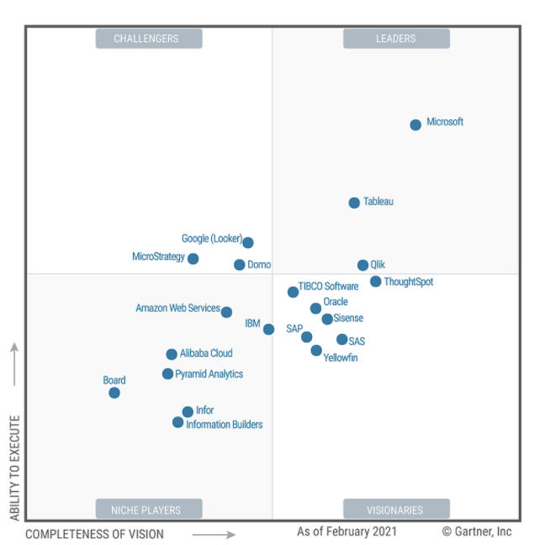

Microsoft Power BI is capable of integrating with all the industry tools like Microsoft Teams, Tasks, Kaizala, etc. for daily needs and quick sharing across the organization, while empowering the users and developers to extract the data from varied data sources like spreadsheets, flatfiles, text-delimited files, ERP, databases, cloud storage and several other structured data warehouses. It has inbuilt capabilities to extract, transform, model and load using in-house languages like DAX and M query. It can also provide cloud operations using Power BI Service and mobility using Power BI mobile which can be deployed only on a smartphone or a tablet. In addition, Power BI is part of the Microsoft Power Platform where one can utilize the ability to automate and/or delegate to a chat bot using Power Automate, Power Apps, or even Power Virtual Agent.

To begin with the design components, we employ the Data analysis development methodology using the following steps:

1. Business / Operational Understanding
2. Data Understanding
3. Data Preparation and Transformation
4. Data modelling and Analysis
5. Validation & testing
6. Deployment

## 2.1 Business / Operational Understanding

We first try and accumulate as much as business or operational understanding as we could based on the industry the data is referring to, and if necessary process cycles or data flow diagrams would be creating to understand the operations of the data. We assess the situation, determine goals and create a plan.

We are hereby dealing with the financial data, for example, Gross Domestic Product (GDP), which measures the size and health of a country’s economy over a period of time. However, an interesting variable here could be perhaps population, which can outplay the role of GDP since this factor can contribute to poverty as well in developing nations. We have aforementioned 12 countries which have been classified into 2 blocs – G7 and BRICS, and a bloc can be defined as a group of countries which share common interests / attributes and work towards a common end result.

For each of these countries over the past 20 years, i.e., from 2001 to 2020, we look into various aspects like Exports and Imports, Foreign Direct Investments (FDI), Energy consumption per 1000 $ GDP, etc., we utilize attributes/dimensions like Inflation rate, GDP per capita, and we try to analyze the economically contributing factors like economic growth / recession, budget highlights from savings and expenditures, trade and value added sectors that could boost or deteriorate the economy’s status quo for each of the countries. Also, we aspire to prepare a forecast to identify either a progressive or a regressive economy. The data shall be understood at a deeper level in order to observe the real-time effect based on the facts published online, as given below.

|  |  |  |  |
| --- | --- | --- | --- |
| **S.No** | **Economic Crisis** | **Year period** | **Affected Countries** |
| 1 | Dot com bubble | 2000-2002 | G7 mostly |
| 2 | September 11 attacks | 2001 | USA |
| 3 | 2008 Financial crisis | 2008-2009 | G7 & BRICS (global) |
| 4 | Russian financial crisis | 2008-2009 | Russia |
| 5 | European sovereign debt crisis | 2009-2019 | G7 excluding Japan and USA |
| 6 | Russian financial crisis | 2014 | Russia |
| 7 | Brazilian Economic crisis | 2014-2017 | Brazil |
| 8 | Chinese Stock market crash | 2015 | China |
| 9 | Covid-19 pandemic recession | 2020 | G7 & BRICS (global) |

## 2.2 Data Understanding

**Data source** - 873b3cb5-e3f7-4398-adef-bce5df4ca81c_Data.csv extracted file from [LINK](https://databank.worldbank.org/source/world-development-indicators)

The dataset comprises of categorical variables like Country name, country code, series name (metric), series code, and the pivoted year-wise continuous data from 2001 to 2020 for each of the following given metrics within the series name column.

A total of 40 metrics have been initially extracted expecting there would be data within. Upon validation, some of the columns would be considered as redundant as we go along and they shall be removed as part of the optimization.

A metadata file is also available that explains what these metrics are.

A new file – Short Names.xlsx has been created which can keep the title length of each of the series values to 30 characters only, which is a requirement in SAS Enterprise guide.

As we can see from the source level itself, some of the columns have nulls, uncharted characters, etc, which would require data preparation.

It is important to focus on multiple aspects within the data in order to build eye-catching visuals like:

* Composition
* Distribution
* Comparison
* Relationship

# 3. Exploration of Data Set

## 3.1 Data Preparation & Transformation

The data preparation, as mentioned earlier, was carried out within SAS Enterprise guide, which could be explained in simple terms upon importing the required datasets using the following steps:

1. Import ‘*873b3cb5-e3f7-4398-adef-bce5df4ca81c_Data.csv’*
2. Import ‘*Short Names.xlsx’*
3. Merge the tables based on the Series Name column
4. Sort the merged table using the Country name column
5. Transpose / Unpivot the year-wise data based on the series names.
6. Split and clean up the Year column to convert it to an ordinal variable.
7. Filter out the missing values in the nominal variable - Country column and remove unnecessary records.
8. Group the countries based on the country names into a Bloc – either G7 or BRICS.
9. Identify the missing values within the continuous variables, and impute them using the Expectation-Maximization method.
10. Identify the currency columns, percentage columns, numeric columns within the continuous variables after cleaning the garbage values.
11. Export the final table into an .xlsx file, which can be used by Power BI desktop.

Alternatively, all the steps mentioned above can be achieved from with the Power BI environment – Power Query editor which can merge, sort, filter, group, transform, slice and dice, pivot / unpivot the data. The following screenshots can highlight these abilities. The imputation method of the missing values is not possible from within power bi, however, we could still replace nulls or jargon values from each of the variables. Hence, we are using SAS only for the data preparation and to unify the insights without disrupting the data integrity.

**Using Power Query Editor**

1. Home tab – Options like Split, group, sort, filter, make first row as headers, choose or remove columns,



1. Transform tab – transpose, pivot, unpivot, fill, etc. In addition, we could also use the ability of R and Python programming from within this tab, for example – imputing values which is natively not possible within Power BI.



1. Add column tab – Custom columns, conditional columns, value parsing, indexing, etc., can be achieved from here.

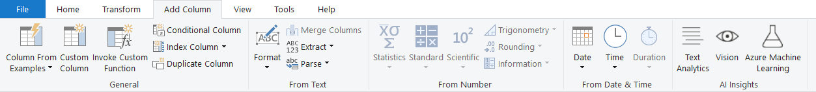

1. Advanced editor – The following steps have been made to prepare the dataset upon exporting from sas.

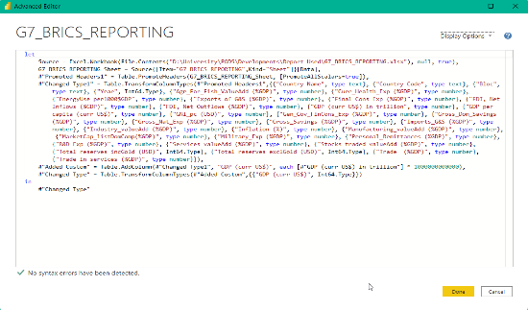

1. G7_BRICS_REPORTING table –

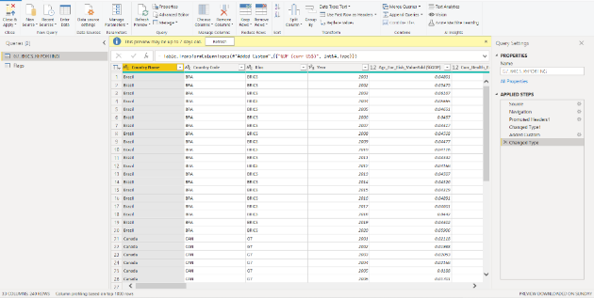

1. Flags table – created using ‘Enter data’ which is essentially hard-coded within Power BI. In a real-world scenario the flags aren’t supposed to change.

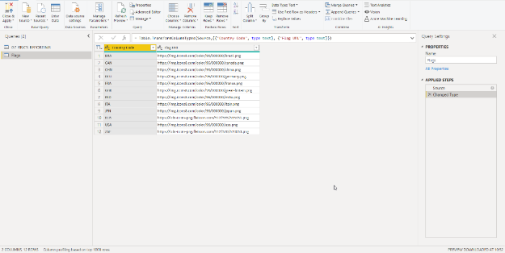

1. Various data formats within Power BI – dates, percentages, currency, Country/Region (for geo-spatial analysis), Image URL (country flag), etc are shown below.

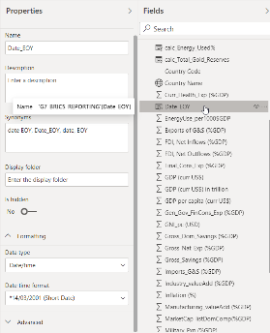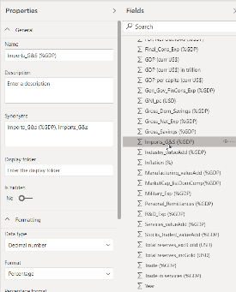

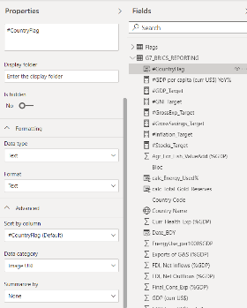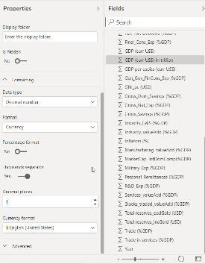

# 4. Investigation of Data Workflows & Proposal for Design of Dashboard

## 4.1 Data Modelling

Upon the completion of Data transformation, we proceed to Data modelling within Power BI. We check for cardinality within the tables and link the tables, and in our case it has one to many relationship between the Flags table and the G7_BRICS_REPORTING table respectively.

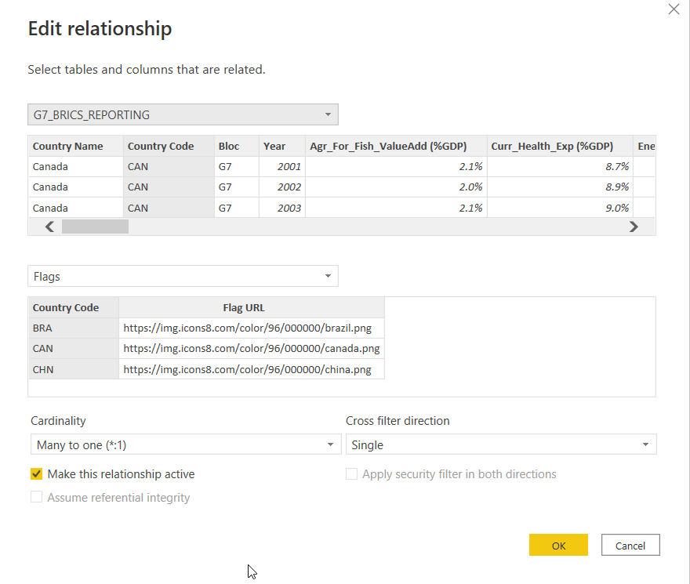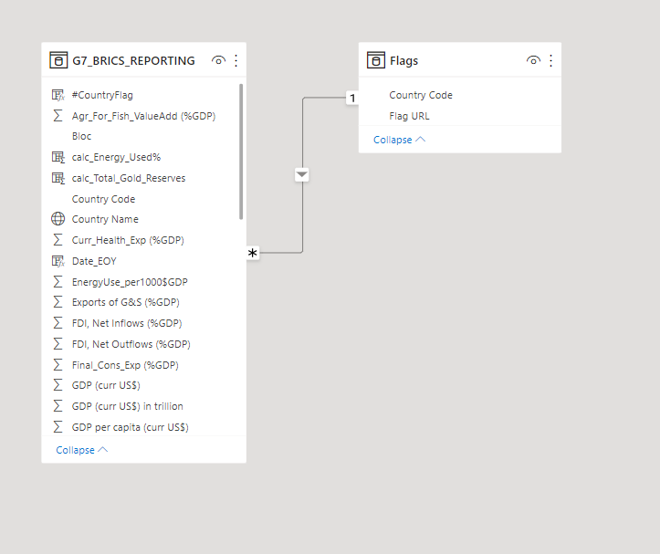

From the design perspective, multiple proofs of concept have been created and it was identified that it is essential to carry out this assignment using the entity as either of the categorical variables – Bloc name or Country name. Bloc name would result only in 2 different colours, whereas Country name could result in 12 different colours in order to be able to differentiate. In order to solve this problem, we go entity-wise to be able to check groups and countries one by one which should keep our dashboard user-friendly, effective, and could help us create appealing visuals using basic or minimal colours. To be able to apply the visuals effectively, GESTALT principles – closure, common fate, continuation, similarity, figure ground, proximity, and symmetry have been used.

A toggle has been created for the summary of the report where the average values of the metrics are quickly contrasted between G7 and BRICS nations with just a switch.

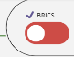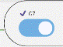

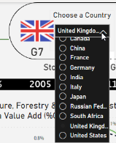For the remaining stories, we go in-depth for each of the countries and delve into each of the countries individually, which would require a single-select filter for Country column as shown below. All the stories, however, have a common slider object (filter) for the years in order to be able to restrict the data to a certain period of time only.

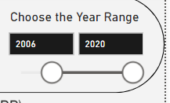

Five different stories can be accessible from a single screen using the following button objects. Summary is where the Bloc is compared. A common header is created.

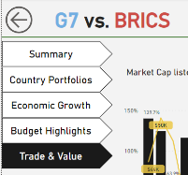

Custom calculated columns are created –

1. Total Gold Reserves = Total reserves incl. Gold – Total reserves excl. Gold.



1. Country flag – Image URL reference – Look Up column to be able to project a flag when a country is selected.



1. Energy used – Convert into %



1. GDP per capita – Year On Year growth rate

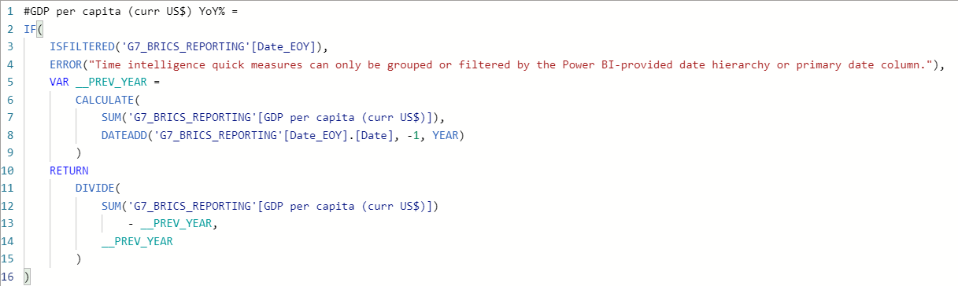

Custom Targets are created for being able to quantify some of the metrics in order to rationalize the argument.

1. Expenditure target

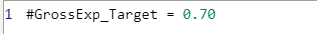

1. GDP Target

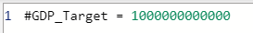

1. GNI target

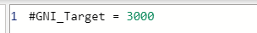

1. Inflation target

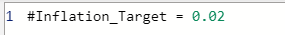

1. Gross Savings target

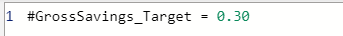

1. Stocks Target



## Data Analysis

### 4.2.1 Summary

1. G7 – On a whole, G7 countries have an average GDP of 4.7 trillion USD, 78.5% of mean gross expenditure, and an average inflation rate of 1.4% for all the years combined. We can observe that Canada and Japan have particularly cherished deflation as well that would definitely boost the economy. Of all the G7 countries, we could observe that the United States of America, despite moderate levels of inflation, had a consistently growing GDP per capita over the last 20 years. Germany and Canada are major contributors of exports and imports as a percentage of GDP. Canada stands at the first position when it comes to FDI, net outflows and the UK stands out when it comes to FDI, net inflows as a percentage of their individual GDP. These values could differ when we look into converted USD values, unlike a portion of the country’s GDP. Canada also spends tremendous amount of money on electrical consumption, possibly due to the cold weather across the landscape, and also we could observe that the United States stands next to Canada when it comes to electrical consumption, since both are neighbors and stiff competitors within the job or business opportunity market.

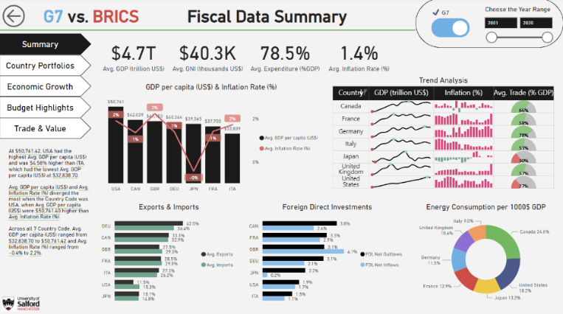

2. BRICS – Since being the emerging nations, this group of countries have relatively weaker economies against their counterparts, with an average GDP of 2.4 trillion USD, an average expenditure of 70.9% and mean inflation rate at 6.8 % over the last 20 years. India has the lowest ratio of GDP per capita to Inflation rate, and the Brazilian trade situation seems to be difficult. Russia and South Africa have been significant players in Trade, as we could see in Exports and Imports chart. Russia has outplayed all the other countries when it comes to FDI, net outflows, and Brazil seems to be the highest beneficiary of the FDI, net inflows, as a percentage of GDP. Russia, similar to Canada, has consumed more energy than any other BRICS nation, and China stands in second place for energy consumption, possibly due to the infrastructure hubs and population density.

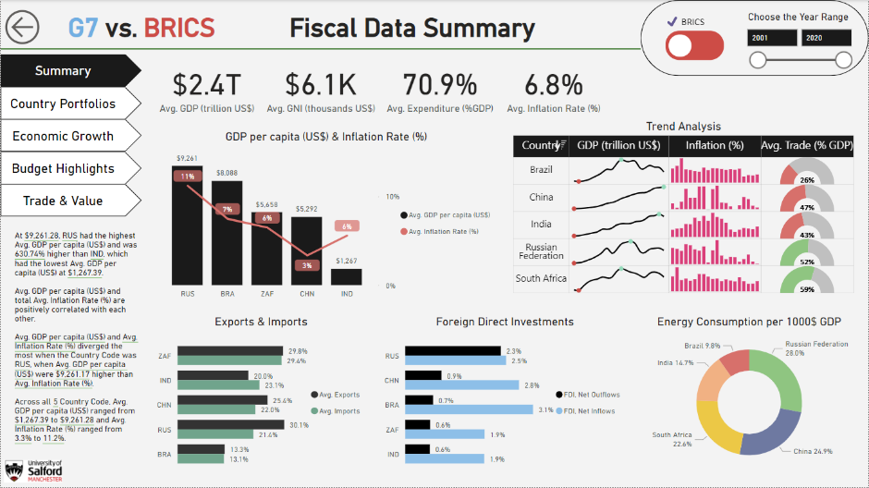

### Country Portfolios

Individual countries can be probed into to observe the status of all the top metrics / KPI that were mentioned earlier. In this case, we look only into certain countries which we are interested in based on the initial observations from the Summary sheet.

1. Brazilian Trade situation – Brazil had an economic crisis from mid 2014 to 2017 due to which we could see the rise of imports and the downfall of exports which have clearly deteriorated the country’s economy and later President Jair Bolsonaro’s leadership had helped reduce the overall inflation rate and steadily improve the country’s trade condition.

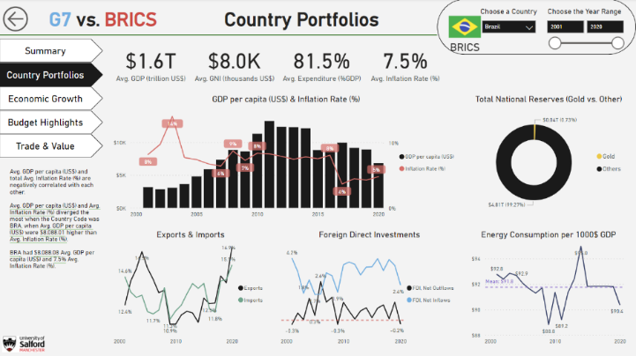

1. Chinese consistent economic growth – Although there were challenges with inflation, population and the 2015 Chinese stock market crash, the country seem to have steadily improved the GDP per capita in relation to the technical advancements and transparent transcontinental business and trade policies. They have the highest gold reserves of 850 billion USD, which accounts to 1.84% of total national reserves.

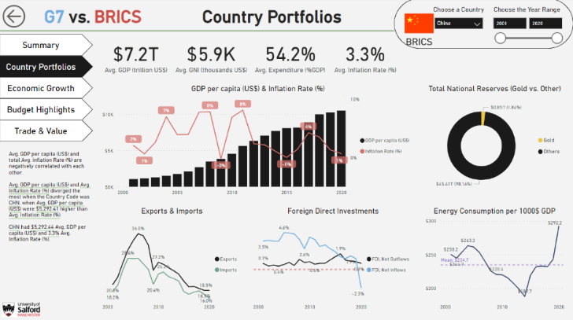

1. Russian trade situation – Russian Exports and Imports have been strong although declining over the last 20 years slowly. The crisis of 2008 and 2014 have played a significant role in determining this, however, Russia still seems to be a strong player in terms of Exports especially and has handled financial crisis without any sudden increase in Imports. The energy consumption however, has spiked in 2019 due to unknown reasons and must have dropped in 2020 due to COVID-19 pandemic.

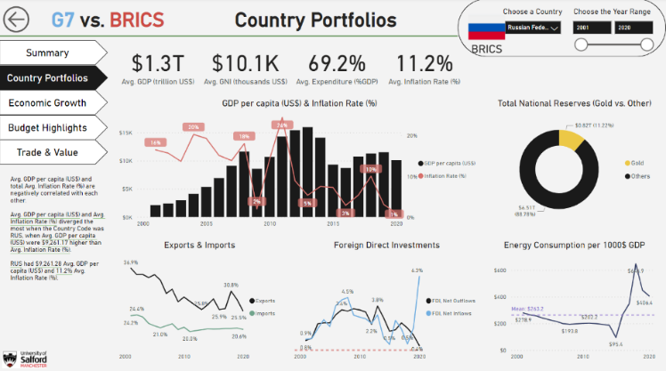

1. India’s economic slowdown – Although the overall GDP per capita consistently improved over the past 20 years, the actual values have only moved from 500 USD to 2000 USD unlike China which now has an approximate value of 10000 USD GDP per capita that started from 1000 USD as of 2001. The inflation rate seems to have been controlled after 2010, FDI net inflows have drastically rised during the pandemic year.

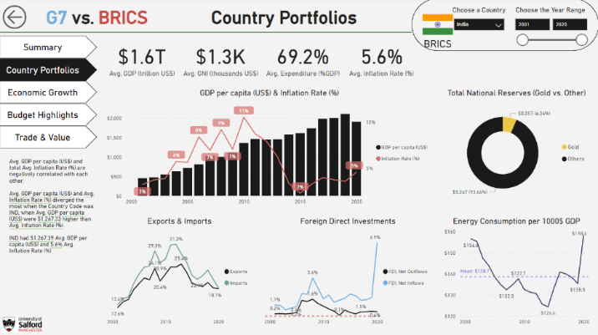

1. South Africa – the country with the least amount of average GDP over the past 20 years.

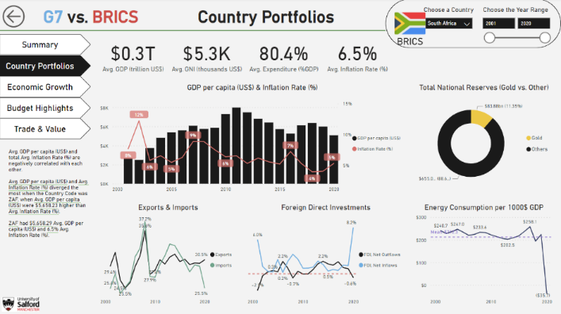

1. USA’s dominance over G7 countries – An average GDP of 15.8 trillion USD, steady economic improvement and with less than 2 % of average inflation rate, USA clearly exercises dominance over the rest of the countries.

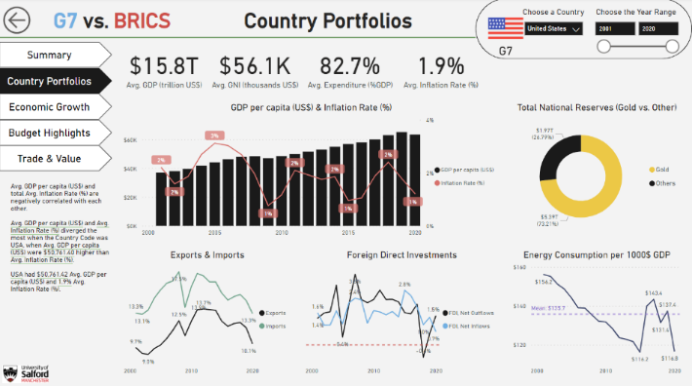

1. UK – Inflation suddenly surged in 2020 due to the pandemic.

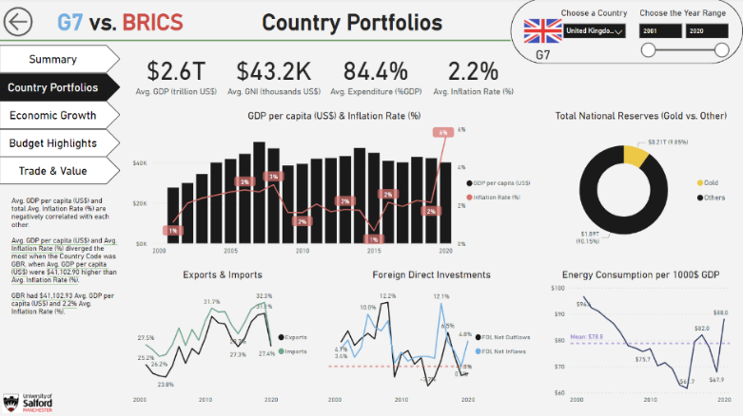

1. Germany –

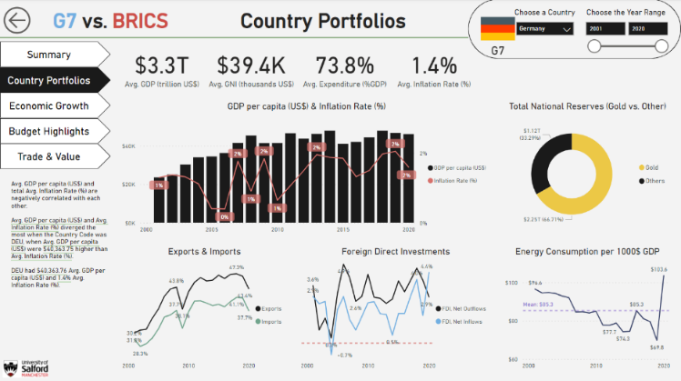

1. France –

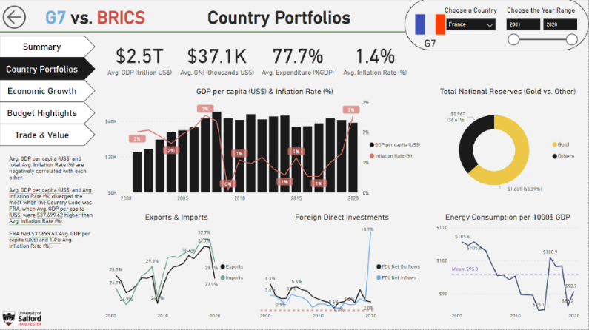

1. Italy –

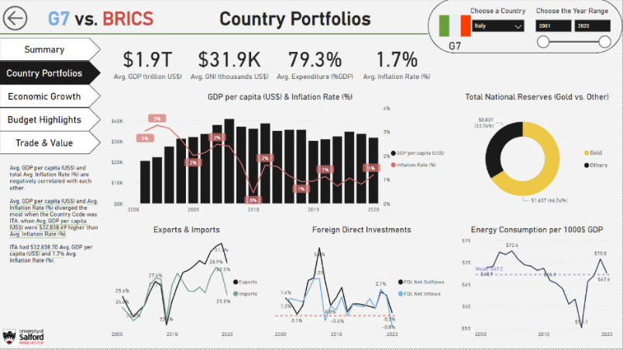

1. Canada –

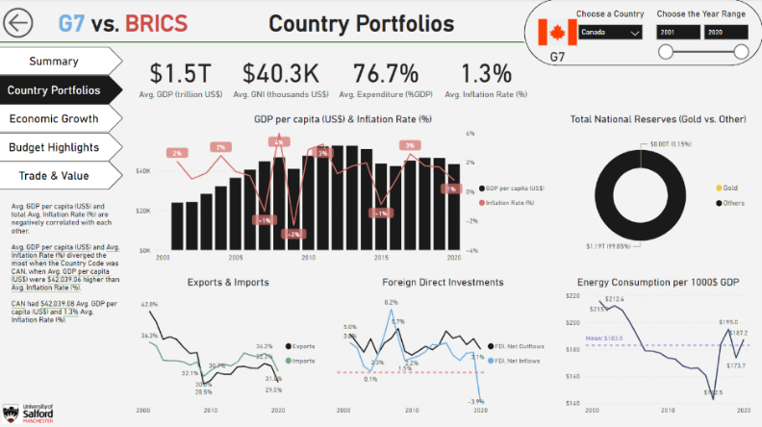

1. Japan -

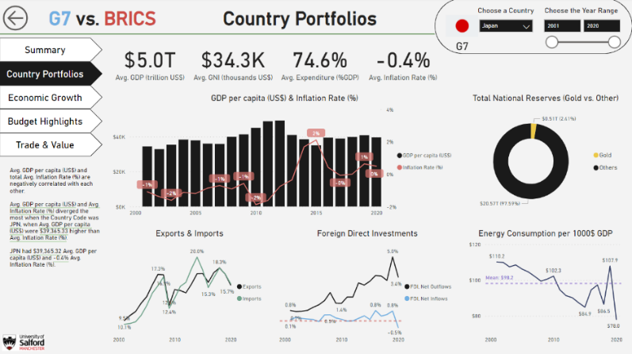

### Economic Growth

* KPI objects have been used along with target values for GDP (1 Trillion USD), GNI (3000 USD), Savings (30%) , Inflation rate (2 %)
* Waterfall chart represents the Year on Year growth or downfall of the GDP per capita.
* GDP and Inflation – Time Series charts and forecasts for the next 3 years with a confidence interval of 95% have been illustrated towards the right.

1. Brazil -

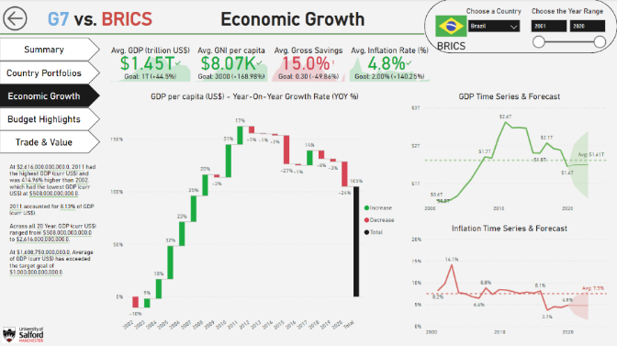

1. India -

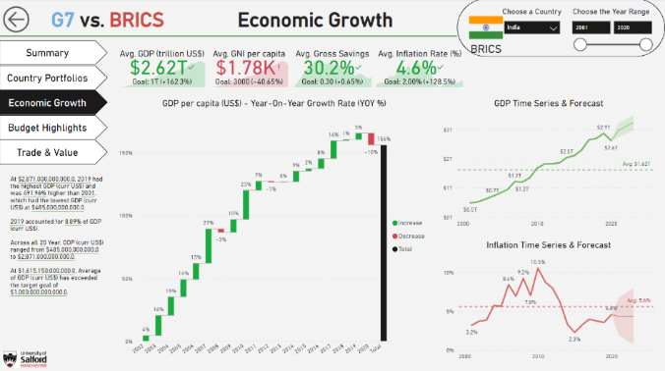

1. China -

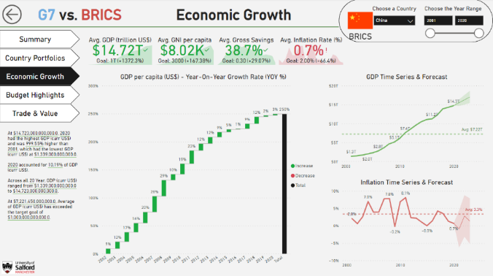

1. South Africa -

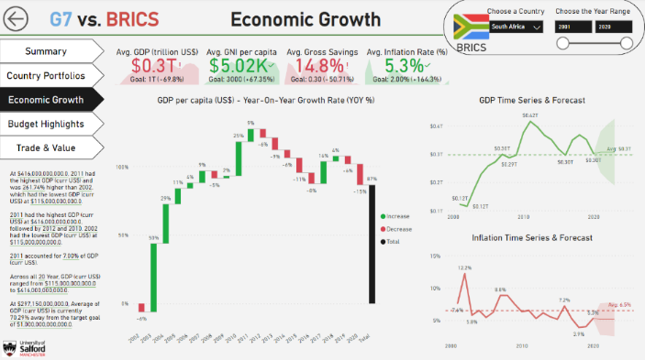

1. Russia –

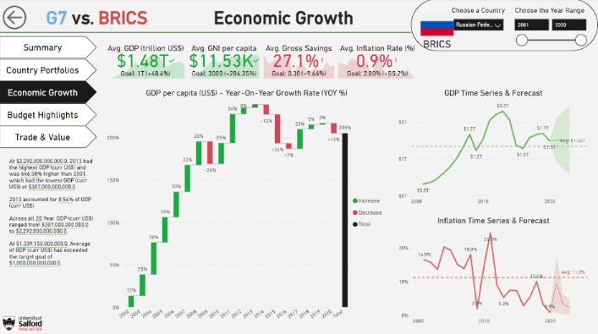

1. UK -

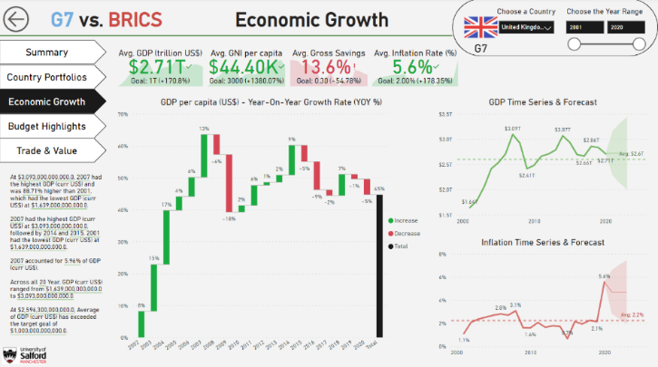

1. Japan –

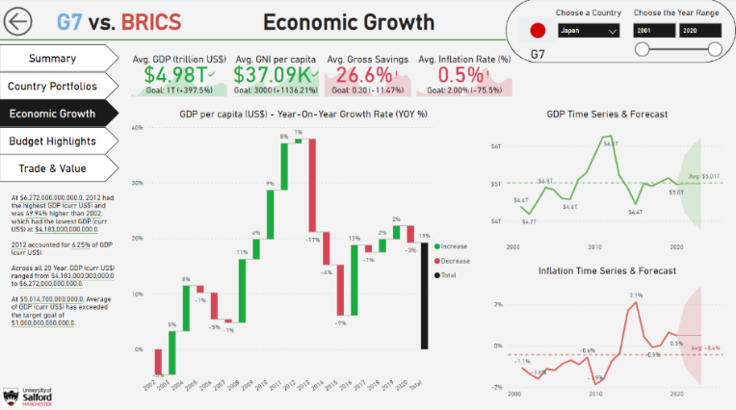

1. Italy -

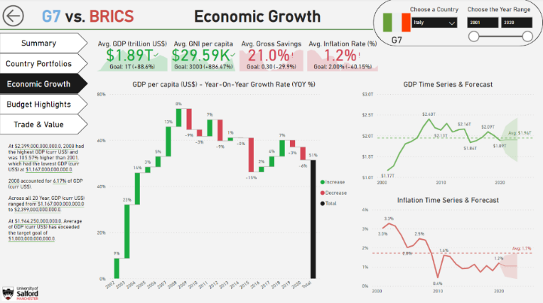

1. Germany –

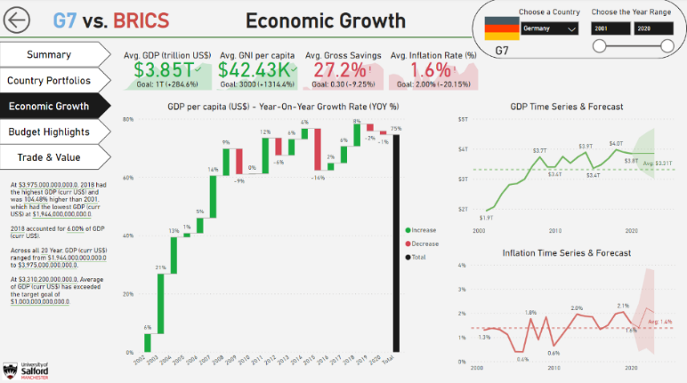

1. France-

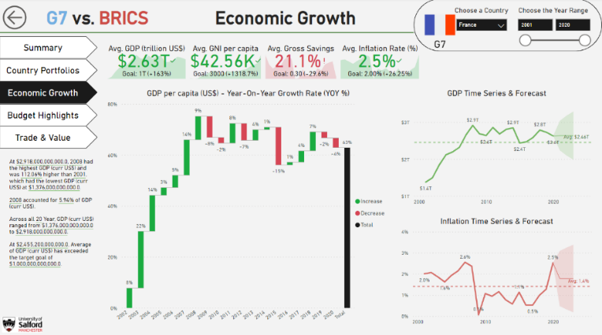

1. Canada –

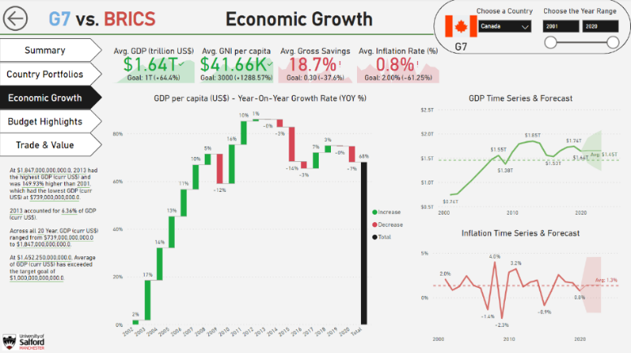

1. USA -

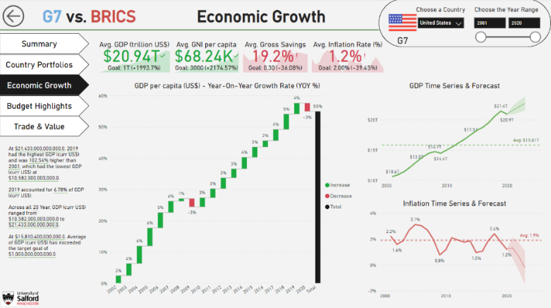

### Budgeting Highlights

* All the G7 countries consistently have more than 70% target as their average expenditures as a percentage of GDP.
* The expenses on health, general governmental expenses, military, research and development have been shown on right along with trends. In addition, we could also see personal remittances and energy consumed trends as well.
* It can be forecasted with 95% confidence interval whether a country could spend more or less going forward based on the existing data.
* China consistently had more savings% than any other country and have spent less than 60% GDP on an average over the last 20 years. However, as per the forecast, China could exceed the 70% target in the next 5 years.

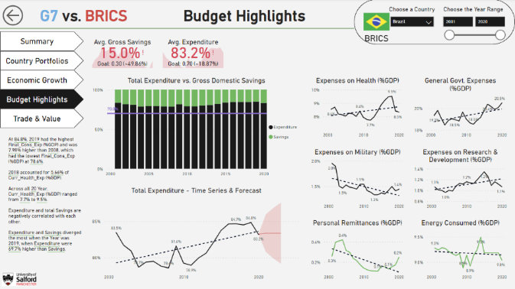

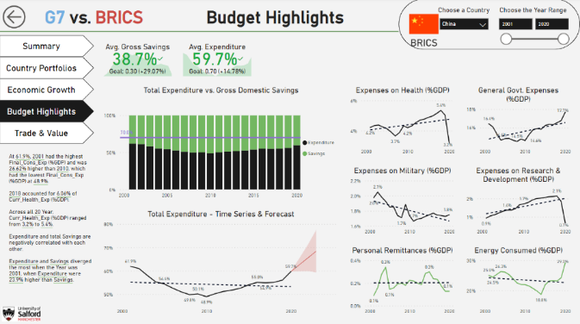

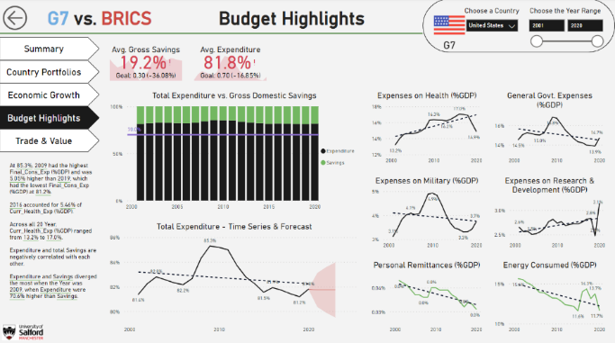

### 4.2.5 Trade & Value

* All the G7 countries have a steady increase in the analogous exports and imports graph, as we could observe the trend. Hence, we could attribute the BRICS nations to this feature mentioning that the trade is either improving or relapsing based on the trend, which could be of various factors.
* Russian, Chinese, South african investments in trade have reduced over time.
* India’s exports and imports trends are improving at a rather slower pace, but the sentiment seems to be positive.
* Brazil’s stance on trade is neutral looking at the bigger picture.
* In addition, we could also see Value adds as a %GDP on the right side of the page along with trends for Agriculture, Forestry and Fishery, Services, Manufacturing and Industry, Stocks traded and trade in services % GDP.

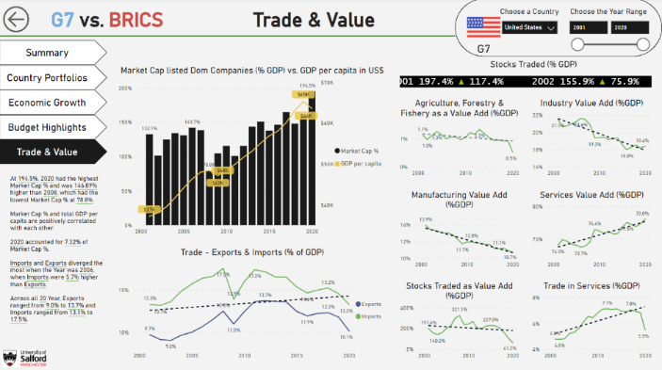

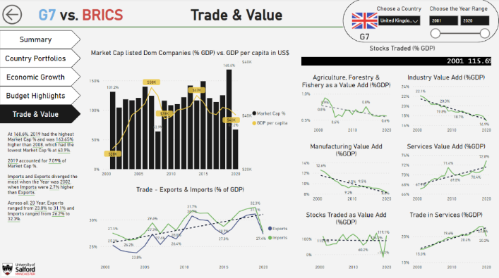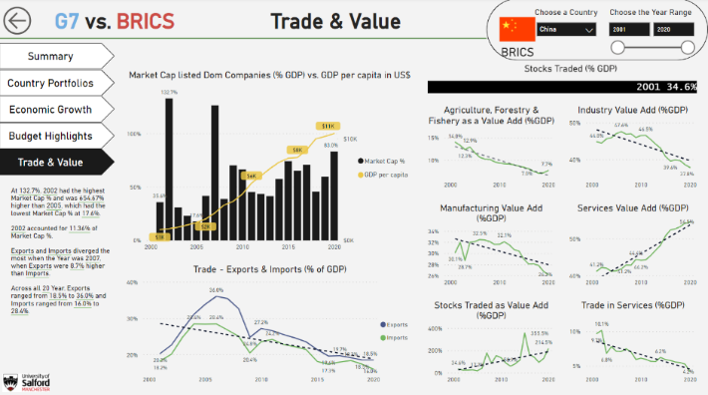

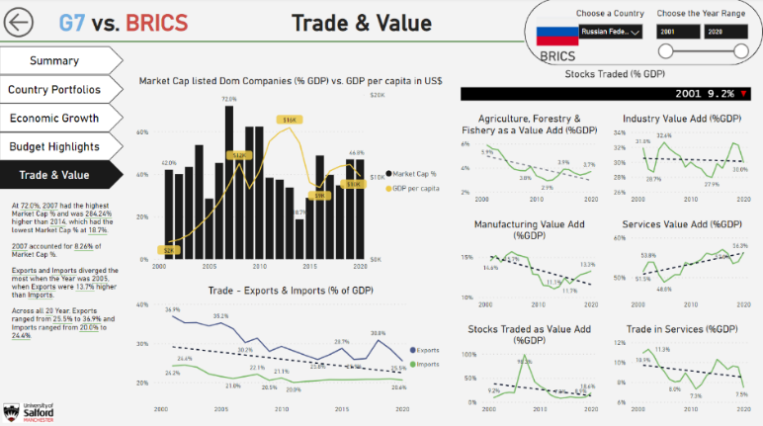

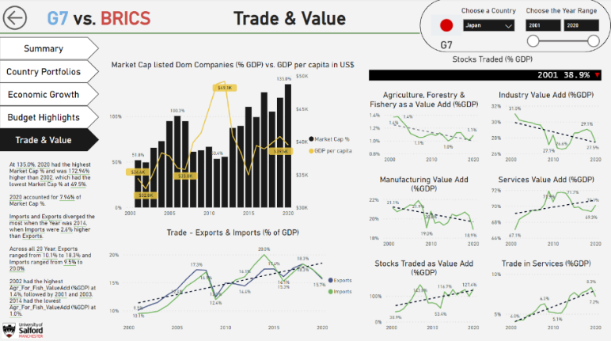

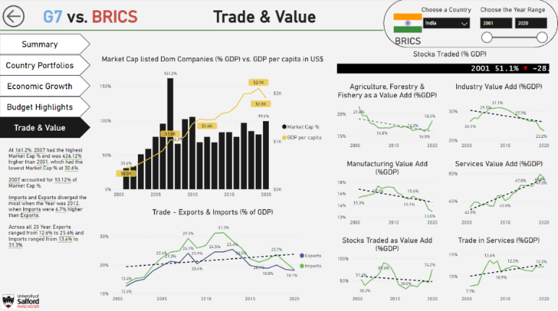

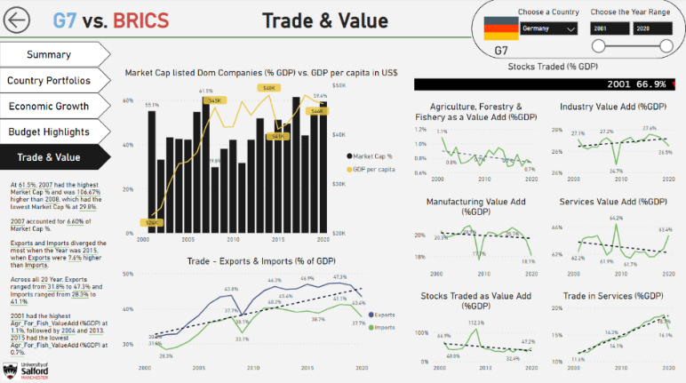

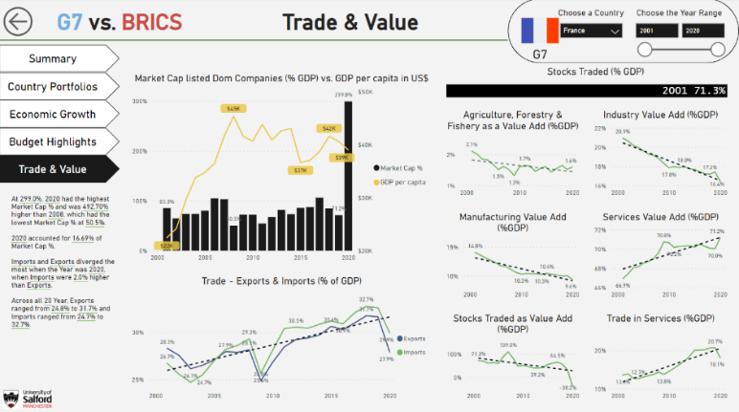

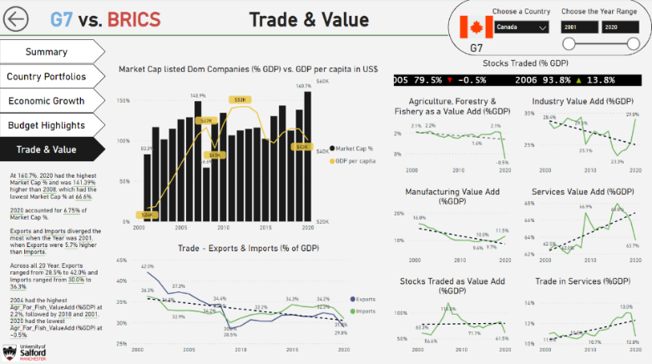

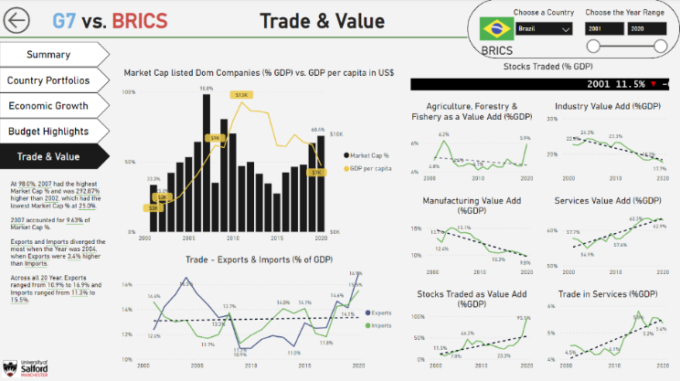

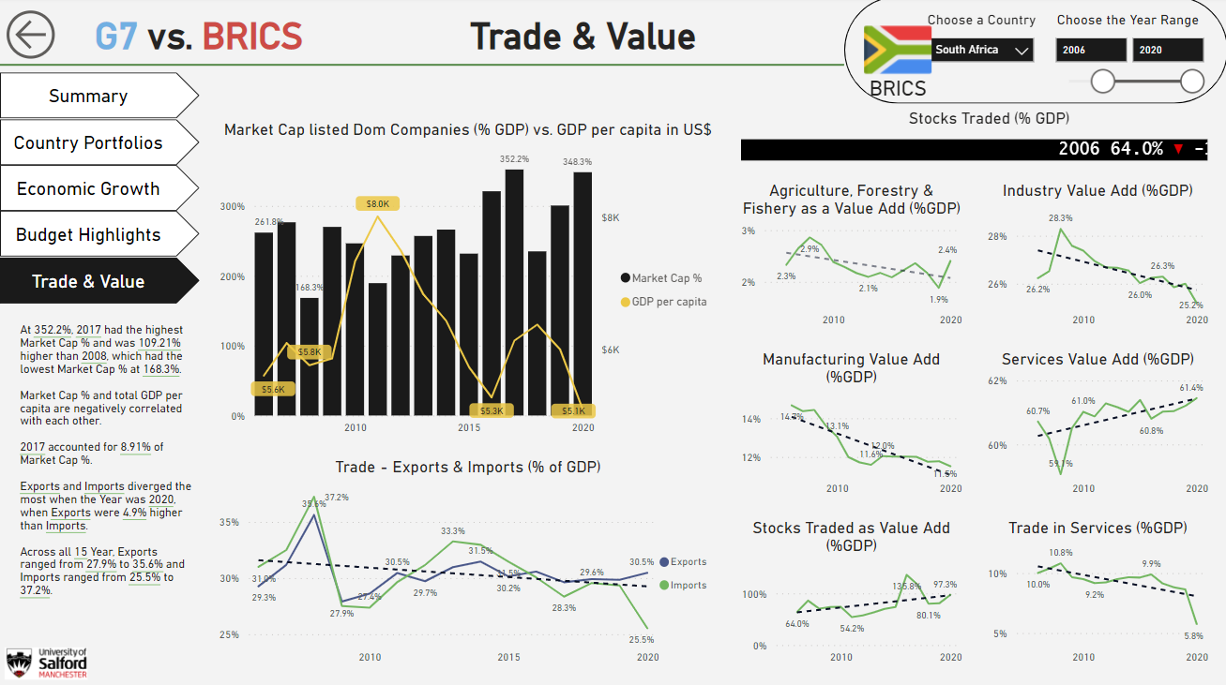

# Discussion

### Validation & Testing

* Top-to-bottom approach has been used to create this report where the key elements would be on the top, and least important elements or objects would be on the bottom of the page.
* A left-to-right approach has been used since a majority of the users glance the report from left to right.
* DAR methodology was implemented to identify if dashboards, analysis or reports, and in this scenario, we are only looking into dashboards and analysis. In case reports were needed, we could apply a switch/toggle to be able to view everything in tabular structures with conditional formatting as necessary.
* Multiple kinds of charts like bar charts – stacked and clustered, pie chart, line chart, combo chart, waterfall chart, smart narrative, kpi object, card objects, image objects, slicers, sliders, buttons, etc
* During the validation, multiple factors like duplicate records, unlikely percentage issues have been considered. An overall evaluation of the existing financial crisis in the real world vs. data have been performed.
* Errors within calculated fields and measures have been resolved.
* Most of the time, dark monochromatic or palette-specific colours only have been used which would help 99% of the users to be able to look into the visuals without any problem pertaining to visual aid or dark modes.
* Data-to-ink ratio has been kept to a minimum, so that the users can focus on the actual context of the visuals.
* Data integrity has been handled when it comes to charts, which wouldn’t exaggerate the numbers, thus baselining them appropriately.
* Target values determine whether the entity selected has properly baselined or not.
* For a report that should reload on a regular basis, as an when there is new data, we could look into scheduled refresh option within Power BI service.

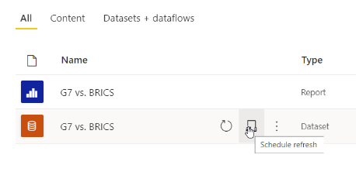

* For large amounts of data, we could perform an incremental refresh that would only load the latest data but not the old data.
* GDPR and Data privacy have also been considered and thus the report has only been shared to an evaluator (Dr. Safwan Umer) who alone can check the report using Power BI service within a personalized workspace. In a real world scenario with multiple users, we can explore the option of Row-level security within Power BI, in order to be able to give a region / country specific access to a user for instance, so that he won’t be able to look into any other countries which could cause a data privacy issue.
* In order to share the report, we would need a Power BI pro license, however, Microsoft offers a free trial, which was activated in this case to be able to share with Dr. Safwan. The trial period is for 60 days.
* One of the known issues is that the multiple sparklines chart that is present on the main page of the report needs to have a license. In the real-time, many organisations allow premium workspaces that allow advanced visuals which could be applied a license if necessary.

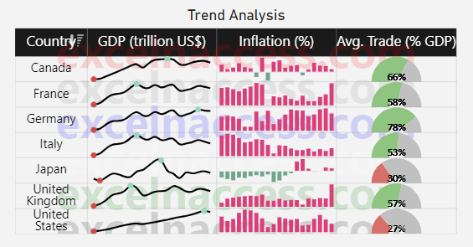

### Deployment

* As part of the deployment, the Power BI report created using Power BI desktop has been published into Power BI service which is a cloud platform where the users can share the reports with peers.
* Name of the workspace – PODS_CourseWork
* Admin – Ambareesh Jonnavittula
* Member – Dr. Safwan Umer

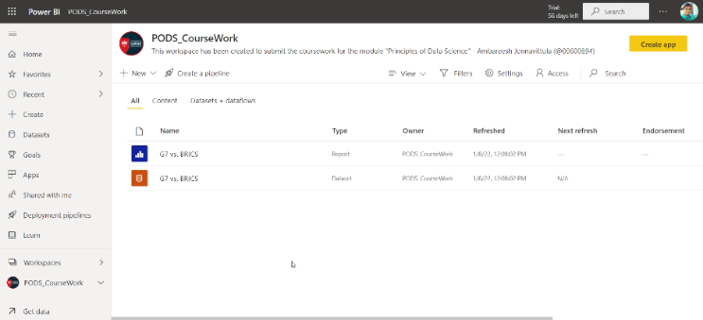



Here is the link:

<https://app.powerbi.com/links/f-ldPtkxIe?ctid=65b52940-f4b6-41bd-833d-3033ecbcf6e1&pbi_source=linkShare>

# Conclusions

Although there have been economic crises over the past 20 years, there could be enough lessons that can be gained from the progressive and regressive countries. USA from G7 and China from BRICS stand on top in the leaderboard and must be considered as an example for the remaining countries in order to be able to tackle economic disasters. There would be challenges for countries with agricultural or tourism background, however, there is always enough to glean from the countries that are leaving away the trail in the form of trends and patterns while reaching to the top.

# Part Two: Statistical Analysis

# Introduction

This data science project is created to analyse financial data for 2 different groups of countries – G7 and BRICS, with an objective to statistically bring out meaningful insights and knowledge from the information present in the form of raw data. We are using SAS Enterprise Guide to import, process, prepare and analyse the financial data.

The purpose of statistical analysis is to try and remove any bias when we review any information, and we could use it to make informed decisions. Using the statistical approach, one can describe the nature of the data, explore the relation of the data to the underlying population, summarized model creation, prove the validity with statistical significance, and if necessary employ predictive analytics to anticipate future trends.

G7 countries are developed nations while BRICS countries are emerging nations. We not only apply comparative analysis, but also group them together to bring out outliers, anomalies, probable misinterpretations, and statistical significance based on meaningful justification and relevance.

# Background Research

SAS Enterprise Guide provides data investigations, code generation for productivity, allows forecasts and promotes a user-friendly approach. Hence, we use this tool in accordance with SAS code of conduct which describes the ethical aspects, market-sensitive information, sensitive and personal sensitive information, etc. The extracted data are organized in datasets listed in The World Bank Data Catalog (the “Datasets”) which are under a Creative Commons Attribution 4.0 International License (CC BY 4.0).

In this project, we are going to look into various aspects including data preparation, preprocessing, imputation methods, descriptive and inferential statistics, univariate and bivariate analysis, outlier detection, correlation & regression as part of the exploratory data analysis, hypothesis testing and principal component analysis. For such a simple dataset, we wouldn’t require sampling, otherwise we could apply random sampling from both the blocs of countries and later validate it against the population.

For data preparation and exploratory data analysis, we could see the code snippets. For the remaining aspects of the project, UI-based functionality has been used in order to showcase that there are various possibilities while using SAS for statistical analysis.

In order to see how the data is flowing, we use the process flow diagram. There are various procedures within SAS using which we could import, check contents, create summary statistics, or even apply correlation or regression, and create charts as well. After the identification/assignment of data types, we apply SQL based procedure in order to filter, sort, group, transpose, merge, or apply any sort of transformation within the given dataset. We also remove the missing values from categorical / discrete variables just in case to allow reproduceability and scalability for the future purposes.

In order to impute the missing values within the continuous variables, we apply multiple imputation procedure that uses ‘Expectation Maximization’ method which uses the bootstrap EM algorithm. This imputation technique is better than the mean imputation technique because it preserves the relationship of the imputed variable with the other variables. This approach is reasonable and would work without any trouble if the percentage of missing data less than or equal to 5% and if the standard error of individual variables is not great. Alternatively, we could use MCMC method (Markov chain Monte Carlo) as well which is a full Bayesian imputation technique, or MCAR (missing completely at random), or MAR (missing at random), or NI (non-ignorable missingness), etc. [iii]

Descriptive statistics gives information about the mean, median, mode, skewness, kurtosis, number of values, number of missing values, etc., which can be viewed using the means procedure in SAS.

Correlation is in general used for association, for example, foggy days and more number of accidents, etc. It is assumed that the association is linear. Pearson Correlation coefficient lies between -1 to 1 which happens to determine whether we have strong / weak or positive or negative correlations. Regression involves estimating the best straight line to summarize the association. Regression, since being a straight line, can be applied mathematically with a formula – **y = ax + b** ; where a is the slope and b is the intercept.

Hypothesis testing is when an assumption is tested based on a population parameter. Hypothesis testing is used to assess the plausibility of a hypothesis by using sample data. P-value determines whether the hypothesis testing succeeded or failed which determines whether the actual value lies within 95% of the confidence interval. A null hypothesis is a theory which says that no statistical relationship and significance exists in a set of given single observed variable, between 2 sets of observations. The counterpart of null hypothesis is termed as alternative hypothesis.

Principal Component Analysis (PCA) technique is used to reduce the dimensionality and increase the interpretability while minimizing the information loss. It effectively maximises variance and produced eigen values determine which component is a key variable.

# Exploration of Data Set

* A process flow diagram representing the sequence of steps to create the necessary analysis and produce results / reports is as shown below.

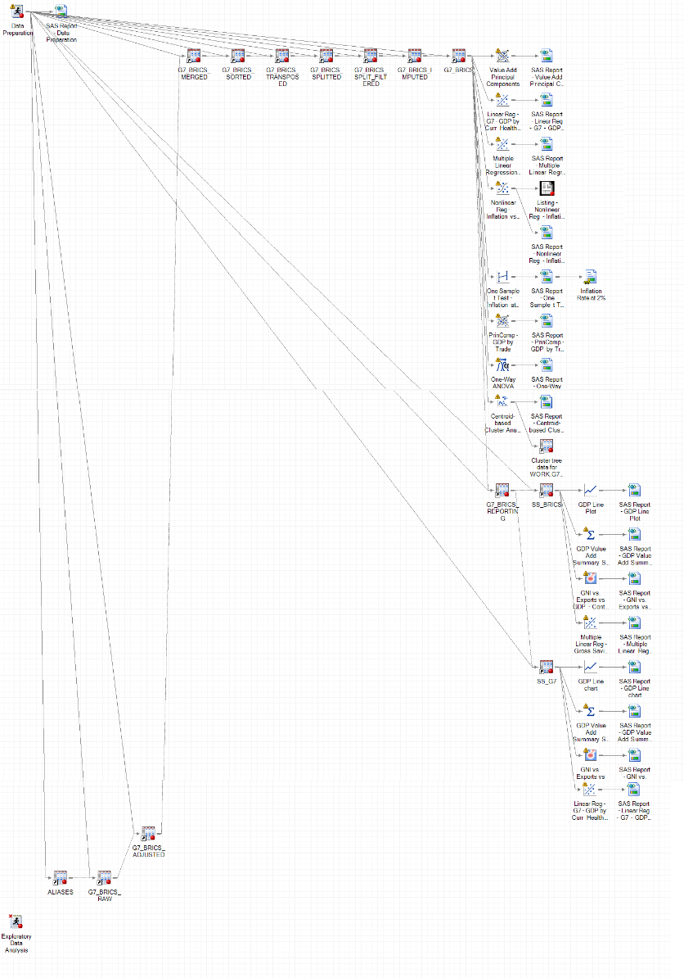

## 3.1 Data Acquisition

1. Import the .csv file where the raw data is present.
2. Import the .xlsx file for shortnames. SAS cannot handle column names greater than 30 characters) and hence we use this second file and merge it with the raw file.

/******************/

/*Data Acquisition*/

/******************/

/* 1. Data Acquisition - File Import - Raw extract file from 'https://databank.worldbank.org/source/world-development-indicators' */

**proc** **import** datafile = 'D:\University\PODS\Datasets\Final\Data_Extract_From_World_Development_Indicators\873b3cb5-e3f7-4398-adef-bce5df4ca81c_Data.csv'

out = G7_BRICS_raw

dbms = csv

REPLACE;

guessingrows= **480** /* if omitted, the default is 20 */

;

**run**;

/* 2. Data Acquisition - File Import - Aliases of Metrics */

**proc** **import** datafile = 'D:\University\PODS\Datasets\Final\Data_Extract_From_World_Development_Indicators\Short Names.xlsx'

out = Aliases

dbms = xlsx

REPLACE;

**run**;

## 3.2 Data Preparation

3. Data types are modified for the raw file and the contents are viewed – continuous, discrete and categorical variables are identified.

/* 3. Data Types are modified */

**DATA** WORK.G7_BRICS_adjusted;

SET WORK.G7_BRICS_raw;

ch_2001 = input('2001 [YR2001]'n, **12.**);

ch_2002 = input('2002 [YR2002]'n, **12.**);

ch_2003 = input('2003 [YR2003]'n, **12.**);

ch_2004 = input('2004 [YR2004]'n, **12.**);

ch_2005 = input('2005 [YR2005]'n, **12.**);

ch_2006 = input('2006 [YR2006]'n, **12.**);

ch_2007 = input('2007 [YR2007]'n, **12.**);

ch_2008 = input('2008 [YR2008]'n, **12.**);

ch_2009 = input('2009 [YR2009]'n, **12.**);

ch_2010 = input('2010 [YR2010]'n, **12.**);

ch_2011 = input('2011 [YR2011]'n, **12.**);

ch_2012 = input('2012 [YR2012]'n, **12.**);

ch_2013 = input('2013 [YR2013]'n, **12.**);

ch_2014 = input('2014 [YR2014]'n, **12.**);

ch_2015 = input('2015 [YR2015]'n, **12.**);

ch_2016 = input('2016 [YR2016]'n, **12.**);

ch_2017 = input('2017 [YR2017]'n, **12.**);

ch_2018 = input('2018 [YR2018]'n, **12.**);

ch_2019 = input('2019 [YR2019]'n, **12.**);

ch_2020 = input('2020 [YR2020]'n, **12.**);

drop '2001 [YR2001]'n '2002 [YR2002]'n '2003 [YR2003]'n '2004 [YR2004]'n '2005 [YR2005]'n '2006 [YR2006]'n '2007 [YR2007]'n '2008 [YR2008]'n '2009 [YR2009]'n '2010 [YR2010]'n '2011 [YR2011]'n '2012 [YR2012]'n '2013 [YR2013]'n '2014 [YR2014]'n '2015 [YR2015]'n '2016 [YR2016]'n '2017 [YR2017]'n '2018 [YR2018]'n '2019 [YR2019]'n '2020 [YR2020]'n;

rename ch_2001='2001 [YR2001]'n ch_2002='2002 [YR2002]'n ch_2003 = '2003 [YR2003]'n ch_2004 = '2004 [YR2004]'n ch_2005 = '2005 [YR2005]'n ch_2006 = '2006 [YR2006]'n ch_2007 = '2007 [YR2007]'n ch_2008 = '2008 [YR2008]'n ch_2009 = '2009 [YR2009]'n ch_2010 = '2010 [YR2010]'n ch_2011 = '2011 [YR2011]'n ch_2012 = '2012 [YR2012]'n ch_2013 = '2013 [YR2013]'n ch_2014 = '2014 [YR2014]'n ch_2015 = '2015 [YR2015]'n ch_2016 = '2016 [YR2016]'n ch_2017 = '2017 [YR2017]'n ch_2018 = '2018 [YR2018]'n ch_2019 = '2019 [YR2019]'n ch_2020 = '2020 [YR2020]'n;

**run**;

**proc** **contents** data=G7_BRICS_adjusted;

**run**;

4. Using PROC SQL, merge the adjusted raw data and aliases tables into one.

/* 4. Merge 2 files - Dataset + Metric Aliases */

/* Aliases are given to maintain the header length of 30 characters only in SAS */

/* Series name & Series code are being excluded to transpose the dataset without any data overlapping */

**PROC** **SQL**;

CREATE TABLE G7_BRICS_merged AS

SELECT t1.'Country Name'n,

t1.'Country Code'n,

/* t1.'Series Name'n, */

t2.'Renamed'n as 'Metric'n,

t1.'2001 [YR2001]'n,

t1.'2002 [YR2002]'n,

t1.'2003 [YR2003]'n,

t1.'2004 [YR2004]'n,

t1.'2005 [YR2005]'n,

t1.'2006 [YR2006]'n,

t1.'2007 [YR2007]'n,

t1.'2008 [YR2008]'n,

t1.'2009 [YR2009]'n,

t1.'2010 [YR2010]'n,

t1.'2011 [YR2011]'n,

t1.'2012 [YR2012]'n,

t1.'2013 [YR2013]'n,

t1.'2014 [YR2014]'n,

t1.'2015 [YR2015]'n,

t1.'2016 [YR2016]'n,

t1.'2017 [YR2017]'n,

t1.'2018 [YR2018]'n,

t1.'2019 [YR2019]'n,

t1.'2020 [YR2020]'n

FROM WORK.G7_BRICS_adjusted t1

LEFT JOIN WORK.ALIASES t2

ON t1.'Series Name'n = t2.'Series Name'n

WHERE t1.'Country Name'n NOT = ''

ORDER BY t1.'Country Name'n,

t1.'Series Name'n;

**QUIT**;

5. Sort the merged data set (Sorting is necessary before the transposing the data).

/* 5. Sort data by Country Name & Country Code */

/* This is to ensure proper data transposition */

**PROC** **SORT**

DATA=WORK.G7_BRICS_merged(KEEP="2001 [YR2001]"n "2002 [YR2002]"n "2003 [YR2003]"n "2004 [YR2004]"n "2005 [YR2005]"n "2006 [YR2006]"n "2007 [YR2007]"n "2008 [YR2008]"n "2009 [YR2009]"n "2010 [YR2010]"n "2011 [YR2011]"n

"2012 [YR2012]"n "2013 [YR2013]"n "2014 [YR2014]"n "2015 [YR2015]"n "2016 [YR2016]"n "2017 [YR2017]"n "2018 [YR2018]"n "2019 [YR2019]"n "2020 [YR2020]"n Metric "Country Name"n "Country Code"n)

OUT=WORK.G7_BRICS_sorted

;

BY "Country Name"n "Country Code"n;

**RUN**;

6. Transpose the sorted table for Years and Metric columns.

/* 6. Transpose the data by Metrics as continuous variables and Year is attributed to a single discrete variable */

**PROC** **TRANSPOSE** DATA=WORK.G7_BRICS_sorted

OUT=WORK.G7_BRICS_transposed(LABEL="Transposed WORK.G7_BRICS_FINAL")

/* PREFIX=Column*/

NAME=Year

LABEL=Label

;

BY "Country Name"n "Country Code"n;

ID Metric;

VAR "2001 [YR2001]"n "2002 [YR2002]"n "2003 [YR2003]"n "2004 [YR2004]"n "2005 [YR2005]"n "2006 [YR2006]"n "2007 [YR2007]"n "2008 [YR2008]"n "2009 [YR2009]"n "2010 [YR2010]"n "2011 [YR2011]"n "2012 [YR2012]"n "2013 [YR2013]"n "2014 [YR2014]"n "2015 [YR2015]"n "2016 [YR2016]"n "2017 [YR2017]"n "2018 [YR2018]"n "2019 [YR2019]"n "2020 [YR2020]"n;

**RUN**;

**QUIT**;

1. Split the Year column to convert it into a discrete variable from a categorical variable.

/* 7. Data Split on Year column*/

**data** WORK.G7_BRICS_splitted;

set WORK.G7_BRICS_transposed;

length yearsplit1-yearsplit2 $**10**;

if year ne ' ' then

yearsplit1=scan(year, **1**, ' ');

if year ne ' ' then

yearsplit2=scan(year, **2**, ' ');

**run**;

1. Filter out the garbage values from rows and columns , and later identify BRICS and G7 countries to group them as individual Blocs.

/* 8. Filtering & Grouping */

**PROC** **SQL**;

CREATE TABLE WORK.G7_BRICS_split_filtered as

SELECT t1.'Country Name'n,

t1.'Country Code'n,

CASE

WHEN t1.'Country Name'n = 'Brazil' THEN 'BRICS'

WHEN t1.'Country Name'n = 'China' THEN 'BRICS'

WHEN t1.'Country Name'n = 'India' THEN 'BRICS'

WHEN t1.'Country Name'n = 'Russian Federation' THEN 'BRICS'

WHEN t1.'Country Name'n = 'South Africa' THEN 'BRICS'

ELSE 'G7'

END as 'Bloc'n,

t1.yearsplit1 as 'Year'n,

t1.'Agr_For_Fish_ValueAdd (%GDP)'n,

t1.BankLiqResv_to_BankAssetsRatio,

t1.'CG_Debt_total (%GDP)'n,

t1.'Curr_Health_Exp (%GDP)'n,

t1.'DebtServOnExtDebt (USD)'n,

t1.'EnergyUse_per1000$GDP'n,

t1.'Expense (%GDP)'n,

t1.'Exports of G&S (%GDP)'n,

t1.'Final_Cons_Exp (%GDP)'n,

t1.'FDI, Net Inflows (%GDP)'n,

t1.'FDI, Net Outflows (%GDP)'n,

t1.'GDP (curr US$)'n,

t1.'GDP per capita (curr US$)'n,

t1.'GNI_pc (USD)'n,

t1.'Gen_Gov_FinCons_Exp (%GDP)'n,

t1.'Govt_Exp_On_Edu_Total (%GDP)'n,

t1.'Gov_Exp_perStu_1 (%GDP pc)'n,

t1.'Gov_Exp_perStu_2 (%GDP pc)'n,

t1.'Gov_Exp_perStu_3 (%GDP pc)'n,

t1.'Gross_Dom_Savings (%GDP)'n,

t1.'Gross_Nat_Exp (%GDP)'n,

t1.'Gross_Savings (%GDP)'n,

t1.'IBRD_loans_IDA_credits (USD)'n,

t1.'Imports_G&S (%GDP)'n,

t1.'Industry_valueAdd (%GDP)'n,

t1.'Inflation (%)'n,

t1.'Manufacturing_valueAdd (%GDP)'n,

t1.'MarketCap_listDomComp(%GDP)'n,

t1.'Military_Exp (%GDP)'n,

t1.'Personal_Remittances (%GDP)'n,

t1.'R&D_Exp (%GDP)'n,

t1.'Services_valueAdd (%GDP)'n,

t1.'Short-term debt(% of tot resv)'n,

t1.'Stocks_traded_valueAdd (%GDP)'n,

t1.'Tax_Rev (%GDP)'n,

t1.'Total_Debt_Service (%GNI)'n,

t1.'Total reserves_incGold (USD)'n,

t1.'Total reserves_exclGold (USD)'n,

t1.'Trade (%GDP)'n,

t1.'Trade in services (%GDP)'n

FROM WORK.G7_BRICS_SPLITTED as t1

WHERE t1.'Country Code'n NOT IS MISSING

ORDER BY t1.'Country Name'n,

t1.'Year'n;

**QUIT**;

1. Of the 40 metrics, we wish to see only the ones with full datasets without any missing values within the variable. Hence, we impute the filtered and grouped table using the Expectation maximisation algorithm within the PROC MI command.

/* 9. Missing values identification & imputation */

/* Multiple Imputation method - using PROC MI (needs to be sorted 1st) */

/* EM algorithm - Expectation-Maximization */

**proc** **mi** data=WORK.G7_BRICS_split_filtered out=WORK.G7_BRICS_imputed seed=**1234** nimpute=**1**;

by 'Country Name'n;

EM;

var 'Agr_For_Fish_ValueAdd (%GDP)'n

'BankLiqResv_to_BankAssetsRatio'n

'CG_Debt_total (%GDP)'n

'Curr_Health_Exp (%GDP)'n

'DebtServOnExtDebt (USD)'n

'EnergyUse_per1000$GDP'n

'Expense (%GDP)'n

'Exports of G&S (%GDP)'n

'fdi, net inflows (%gdp)'n

'fdi, net outflows (%gdp)'n

'Final_Cons_Exp (%GDP)'n

'gdp (curr us$)'n

'gdp per capita (curr us$)'n

'Gen_Gov_FinCons_Exp (%GDP)'n

'GNI_pc (USD)'n

'Gov_Exp_perStu_1 (%GDP pc)'n

'Gov_Exp_perStu_2 (%GDP pc)'n

'Gov_Exp_perStu_3 (%GDP pc)'n

'Govt_Exp_On_Edu_Total (%GDP)'n

'Gross_Dom_Savings (%GDP)'n

'Gross_Nat_Exp (%GDP)'n

'Gross_Savings (%GDP)'n

'IBRD_loans_IDA_credits (USD)'n

'Imports_G&S (%GDP)'n

'Industry_valueAdd (%GDP)'n

'Inflation (%)'n

'Manufacturing_valueAdd (%GDP)'n

'MarketCap_listDomComp(%GDP)'n

'Military_Exp (%GDP)'n

'Personal_Remittances (%GDP)'n

'r&d_exp (%gdp)'n

'Services_valueAdd (%GDP)'n

'Short-term debt(% of tot resv)'n

'Stocks_traded_valueAdd (%GDP)'n

'Tax_Rev (%GDP)'n

'Total reserves_exclGold (USD)'n

'Total reserves_incGold (USD)'n

'Total_Debt_Service (%GNI)'n

'Trade (%GDP)'n

'Trade in services (%GDP)'n;

**run**;

/*Validation check - Total Observations -> 240 = 12 countries * 20 years */

**proc** **contents** data=WORK.G7_BRICS_imputed;

**run**;

Now we could identify using PROC MEANS whether there are still any missing values post-imputation.

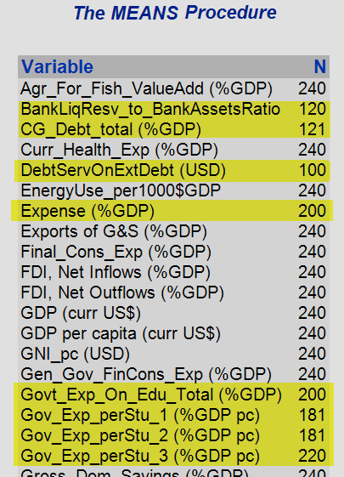

1. Hence we make an effort to remove the redundant missing value columns and keep only the ones which are having 240 observations in each variable.

/* 10. Post-Imputation Identification & Filtering of missing observations in a variable */

/* All the variables that have 240 observations each will only be picked for a best-fit model */

**proc** **means** data = WORK.G7_BRICS_imputed N;

**run**;

**PROC** **SQL**;

CREATE TABLE WORK.G7_BRICS as

SELECT 'Country Name'n,

'Country Code'n,

'Bloc'n,

Year,

ROUND('Agr_For_Fish_ValueAdd (%GDP)'n, **0.001**) as 'Agr_For_Fish_ValueAdd (%GDP)'n,

ROUND('Curr_Health_Exp (%GDP)'n, **0.001**) as 'Curr_Health_Exp (%GDP)'n,

ROUND('EnergyUse_per1000$GDP'n, **0.001**) as 'EnergyUse_per1000$GDP'n,

ROUND('Exports of G&S (%GDP)'n, **0.001**) as 'Exports of G&S (%GDP)'n,

ROUND('Final_Cons_Exp (%GDP)'n, **0.001**) as 'Final_Cons_Exp (%GDP)'n,

ROUND('FDI, Net Inflows (%GDP)'n, **0.001**) as 'FDI, Net Inflows (%GDP)'n,

ROUND('FDI, Net Outflows (%GDP)'n, **0.001**) as 'FDI, Net Outflows (%GDP)'n,

ROUND('GDP (curr US$)'n / **1000000000000**, **0.001**) as 'GDP (curr US$) in trillion'n,

ROUND('GDP per capita (curr US$)'n, **0.001**) as 'GDP per capita (curr US$)'n,

ROUND('GNI_pc (USD)'n, **0.001**) as 'GNI_pc (USD)'n,

ROUND('Gen_Gov_FinCons_Exp (%GDP)'n, **0.001**) as 'Gen_Gov_FinCons_Exp (%GDP)'n,

ROUND('Gross_Dom_Savings (%GDP)'n, **0.001**) as 'Gross_Dom_Savings (%GDP)'n,

ROUND('Gross_Nat_Exp (%GDP)'n, **0.001**) as 'Gross_Nat_Exp (%GDP)'n,

ROUND('Gross_Savings (%GDP)'n, **0.001**) as 'Gross_Savings (%GDP)'n,

ROUND('Imports_G&S (%GDP)'n, **0.001**) as 'Imports_G&S (%GDP)'n,

ROUND('Industry_valueAdd (%GDP)'n, **0.001**) as 'Industry_valueAdd (%GDP)'n,

ROUND('Inflation (%)'n, **0.001**) as 'Inflation (%)'n,

ROUND('Manufacturing_valueAdd (%GDP)'n, **0.001**) as 'Manufacturing_valueAdd (%GDP)'n,

ROUND('MarketCap_listDomComp(%GDP)'n, **0.001**) as 'MarketCap_listDomComp(%GDP)'n,

ROUND('Military_Exp (%GDP)'n, **0.001**) as 'Military_Exp (%GDP)'n,

ROUND('Personal_Remittances (%GDP)'n, **0.001**) as 'Personal_Remittances (%GDP)'n,

ROUND('R&D_Exp (%GDP)'n, **0.001**) as 'R&D_Exp (%GDP)'n,

ROUND('Services_valueAdd (%GDP)'n, **0.001**) as 'Services_valueAdd (%GDP)'n,

ROUND('Stocks_traded_valueAdd (%GDP)'n, **0.001**) as 'Stocks_traded_valueAdd (%GDP)'n,

ROUND('Total reserves_incGold (USD)'n, **0.001**) as 'Total reserves_incGold (USD)'n,

ROUND('Total reserves_exclGold (USD)'n, **0.001**) as 'Total reserves_exclGold (USD)'n,

ROUND('Trade (%GDP)'n, **0.001**) as 'Trade (%GDP)'n,

ROUND('Trade in services (%GDP)'n, **0.001**) as 'Trade in services (%GDP)'n

FROM WORK.G7_BRICS_imputed

WHERE 'Country Code'n NOT IS MISSING

ORDER BY 'Country Name'n,

'Year'n;

**QUIT**;

/*Validation check - Total Observations -> 240 = 12 countries * 20 years */

**proc** **means** data = WORK.G7_BRICS N;

**run**;

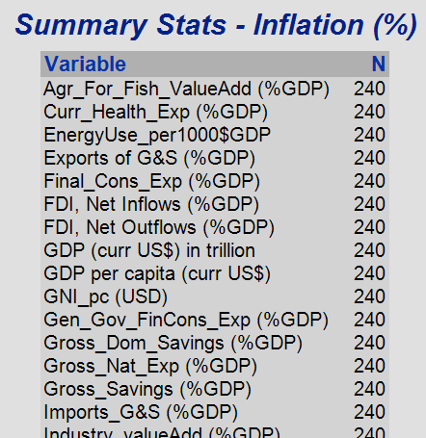

1. Create a new table for reporting purposes within Power BI.

/* 11. Create a new table for reporting purposes - Power BI*/

/* All the % based variables are divided by 100 to utilize in Power BI directly to eliminate redundancy */

**PROC** **SQL**;

CREATE TABLE WORK.G7_BRICS_reporting as

SELECT 'Country Name'n,

'Country Code'n,

'Bloc'n,

Year,

'Agr_For_Fish_ValueAdd (%GDP)'n / **100** as 'Agr_For_Fish_ValueAdd (%GDP)'n,

'Curr_Health_Exp (%GDP)'n / **100** as 'Curr_Health_Exp (%GDP)'n,

'EnergyUse_per1000$GDP'n,

'Exports of G&S (%GDP)'n / **100** as 'Exports of G&S (%GDP)'n,

'Final_Cons_Exp (%GDP)'n / **100** as 'Final_Cons_Exp (%GDP)'n,

'FDI, Net Inflows (%GDP)'n / **100** as 'FDI, Net Inflows (%GDP)'n,

'FDI, Net Outflows (%GDP)'n / **100** as 'FDI, Net Outflows (%GDP)'n,

'GDP (curr US$) in trillion'n,

'GDP per capita (curr US$)'n,

'GNI_pc (USD)'n,

'Gen_Gov_FinCons_Exp (%GDP)'n / **100** as 'Gen_Gov_FinCons_Exp (%GDP)'n,

'Gross_Dom_Savings (%GDP)'n / **100** as 'Gross_Dom_Savings (%GDP)'n,

'Gross_Nat_Exp (%GDP)'n / **100** as 'Gross_Nat_Exp (%GDP)'n,

'Gross_Savings (%GDP)'n / **100** as 'Gross_Savings (%GDP)'n,

'Imports_G&S (%GDP)'n / **100** as 'Imports_G&S (%GDP)'n,

'Industry_valueAdd (%GDP)'n / **100** as 'Industry_valueAdd (%GDP)'n,

'Inflation (%)'n / **100** as 'Inflation (%)'n,

'Manufacturing_valueAdd (%GDP)'n / **100** as 'Manufacturing_valueAdd (%GDP)'n,

'MarketCap_listDomComp(%GDP)'n / **100** as 'MarketCap_listDomComp(%GDP)'n,

'Military_Exp (%GDP)'n / **100** as 'Military_Exp (%GDP)'n,

'Personal_Remittances (%GDP)'n / **100** as 'Personal_Remittances (%GDP)'n,

'R&D_Exp (%GDP)'n / **100** as 'R&D_Exp (%GDP)'n,

'Services_valueAdd (%GDP)'n / **100** as 'Services_valueAdd (%GDP)'n,

'Stocks_traded_valueAdd (%GDP)'n / **100** as 'Stocks_traded_valueAdd (%GDP)'n,

'Total reserves_incGold (USD)'n,

'Total reserves_exclGold (USD)'n,

'Trade (%GDP)'n / **100** as 'Trade (%GDP)'n,

'Trade in services (%GDP)'n / **100** as 'Trade in services (%GDP)'n

FROM WORK.G7_BRICS

WHERE 'Country Code'n NOT IS MISSING

ORDER BY 'Country Name'n,

'Year'n;

**QUIT**;

1. Export this reporting table to .xlsx format within a given path and enable replace in order to run the code multiple times without errors.

/* 12. Data Preparation/Cleaning completed - File Export (xlsx)*/

**proc** **export**

data=WORK.G7_BRICS_reporting

dbms=xlsx

outfile="D:\University\PODS\Developments\Report Used\G7_BRICS_REPORTING.xlsx"

replace;

**run**;

1. Subsetting the data into multiple groups – G7 and BRICS for independent statistical analysis.

/* 13. Data Subsetting into 2 groups - G7 & BRICS (for Comparative Analysis) */

/* Data Subset - BRICS */

**DATA** WORK.ss_BRICS;

SET G7_BRICS;

IF ('Bloc'n = 'G7') THEN

DELETE;

**RUN**;

/* Data Subset - G7 */

**DATA** WORK.ss_G7;

SET G7_BRICS;

IF ('Bloc'n = 'BRICS') THEN

DELETE;

**RUN**;

## 3.3 Exploratory Data Analysis

1. Observe the contents using PROC contents within the final dataset.

2. In order to see only the first 50 observations within the dataset, we could use PROC PRINT.

/******************/

/* Exploratory Data Analysis */

/******************/

/* 1. Data at a Glance */

/* Checking the contents of the dataset */

**proc** **contents** data=WORK.G7_BRICS;

**run**;

/* Taking a look at the dataset for only top 50 records */

**proc** **print** data=WORK.G7_BRICS (obs=**50**);

title 'G7_BRICS Dataset Ready - Top 50 observations';

**run**;

/* 2. Unique values for categorical variables*/

**proc** **sql**;

select

count(distinct 'Country Name'n) as 'Country Name'n,

count(distinct 'Country Code'n) as 'Country Code'n,

count(distinct 'Year'n) as 'Year'n

from WORK.G7_BRICS;

**quit**;

/* 3. Descriptive statistics */

**proc** **means** data=WORK.G7_BRICS n nmiss mean median mode var std kurtosis skewness min max range q1 q3 qrange stderr;

title 'G7_BRICS - Descriptive Statistics';

**run**;

/* 4. Univariate Analysis*/

/* Statistical Analysis performed on a single variable - Histograms */

**proc** **univariate** data=WORK.G7_BRICS novarcontents;

title 'Current Health Expenditure (%GDP) - G7 vs. BRICS';

class 'Bloc'n;

var 'Curr_Health_Exp (%GDP)'n;

histogram 'Curr_Health_Exp (%GDP)'n;

**run**;

3. Unique values are observed in categorical variables.

4. Descriptive statistics are observed using PROC MEANS as shown below.

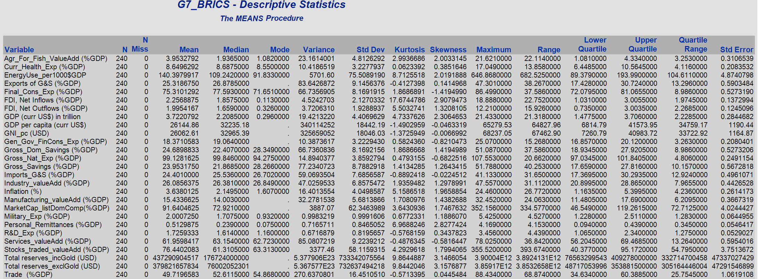

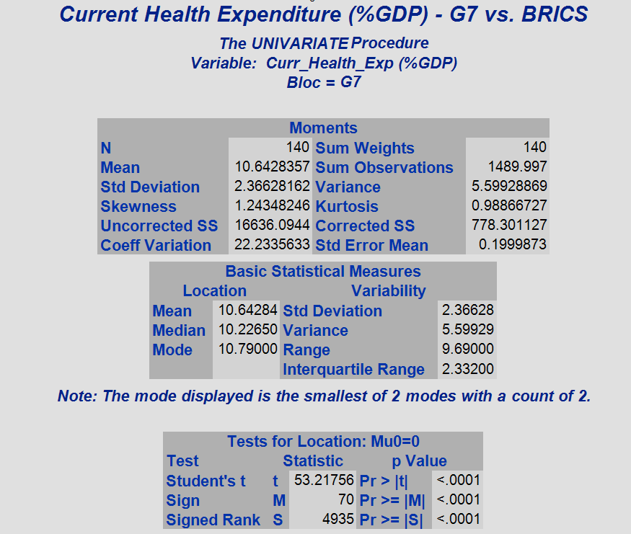5. Univariate analysis –

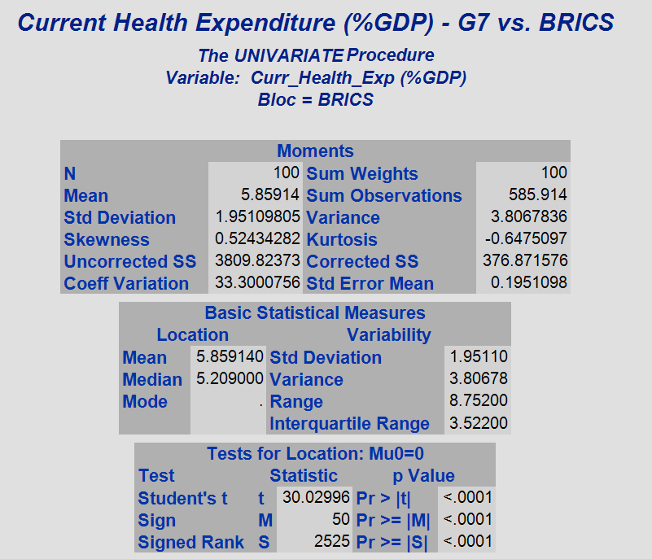

We can see the current health expenditure as a % GDP between G7 and BRICS countries. As expected G7 countries are wealthier, so they tend to promote better health conditions to their residents.

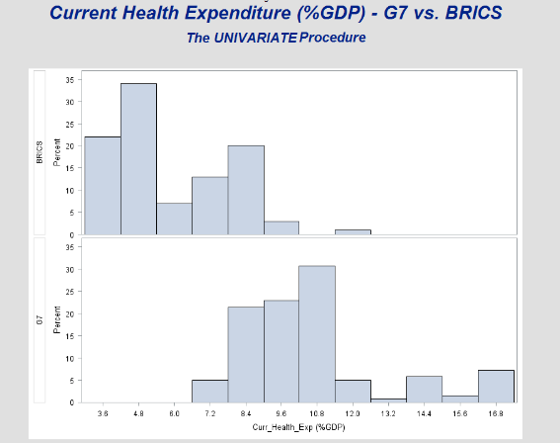

Skewness and Kurtosis -

/* Example - Right-skewed & Leptokurtic */

ods graphics / reset width=**6.4**in height=**4.8**in imagemap;

**proc** **sgplot** data=WORK.G7_BRICS;

title 'Distribution of FDI, Net Inflows (%GDP)';

histogram 'fdi, net inflows (%gdp)'n /;

density 'fdi, net inflows (%gdp)'n ;

density 'fdi, net inflows (%gdp)'n / type= kernel;

keylegend / location=inside position=topright across=**1** noborder;

yaxis grid;

**run**;

/* Example - Left-skewed & Platykurtic */

ods graphics / reset width=**6.4**in height=**4.8**in imagemap;

**proc** **sgplot** data=WORK.G7_BRICS;

title 'Distribution of Services_valueAdd (%GDP)';

histogram 'Services_valueAdd (%GDP)'n/;

density 'Services_valueAdd (%GDP)'n ;

density 'Services_valueAdd (%GDP)'n / type= kernel;

yaxis grid;

**run**;

* Distribution of FDI Net inflows (% of GDP) tends to be right-skewed and leptokurtic.
* Distribution of Services as a value add (% of GDP) seems to be left-skewed and slightly platykurtic.

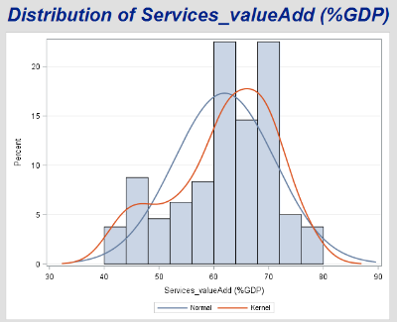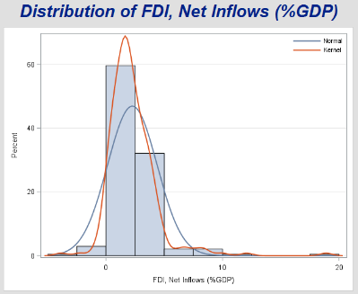

6. Bivariate Analysis –

/* 5. Bivariate Analysis */

ods graphics / reset width=**6.4**in height=**4.8**in imagemap;

**proc** **sgplot** data=WORK.G7_BRICS;

title 'GDP per capita (USD) vs. Services_valueAdd (%GDP)';

scatter x='Services_valueAdd (%GDP)'n y='gdp per capita (curr us$)'n /;

xaxis grid;

yaxis grid;

**run**;

ods graphics / reset;

/* Histograms - merged */

**proc** **sgplot** data=WORK.G7_BRICS nocycleattrs;

title 'Distribution of Exports vs. Imports';

histogram 'Exports of G&S (%GDP)'n / fillattrs=graphdata1 name='E' binstart=**0** binwidth=**0.8** transparency=**0.5**;

density 'Exports of G&S (%GDP)'n / lineattrs=graphdata1;

histogram 'Imports_G&S (%GDP)'n / fillattrs=graphdata2 name='I' binstart=**0** binwidth=**0.8** transparency=**0.5**;

density 'Imports_G&S (%GDP)'n / lineattrs=graphdata2;

keylegend 'E' 'I' / location=inside position=topright across=**1** noborder;

yaxis offsetmin=**0**;

xaxis display=(nolabel);

**run**;

/* Histograms - merged */

**proc** **sgplot** data=WORK.G7_BRICS nocycleattrs;

title 'Distribution of Final Consumption Expenses vs. Gross Dom Savings';

histogram 'Final_Cons_Exp (%GDP)'n / fillattrs=graphdata1 name='E' binstart=**0** binwidth=**1.0** transparency=**0.5**;

density 'Final_Cons_Exp (%GDP)'n / lineattrs=graphdata1;

histogram 'Gross_Dom_Savings (%GDP)'n / fillattrs=graphdata2 name='S' binstart=**0** binwidth=**1.0** transparency=**0.5**;

density 'Gross_Dom_Savings (%GDP)'n / lineattrs=graphdata2;

keylegend 'E' 'S' / location=inside position=topright across=**1** noborder;

yaxis offsetmin=**0**;

xaxis display=(nolabel);

**run**;

1. GDP per capita & Services Value add seem to have a linear relationship, which we could discover in correlation or regression.

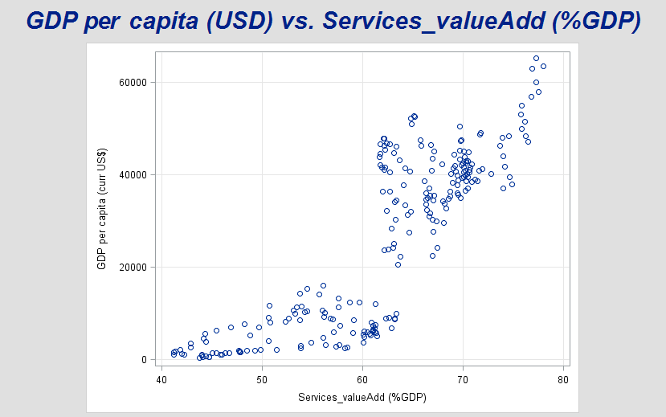

* 1. Distribution of Imports and Exports

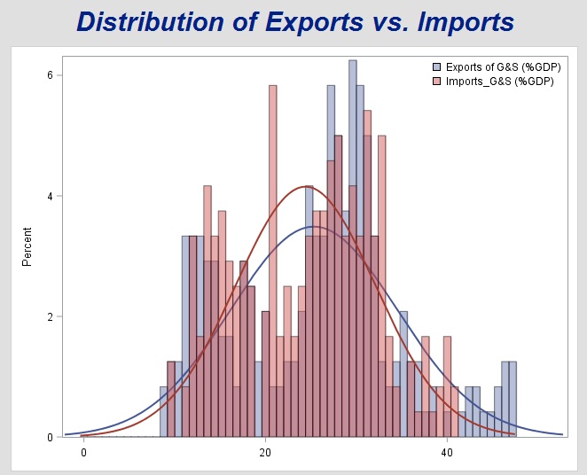

1. Distribution of Expenditure vs. Savings.

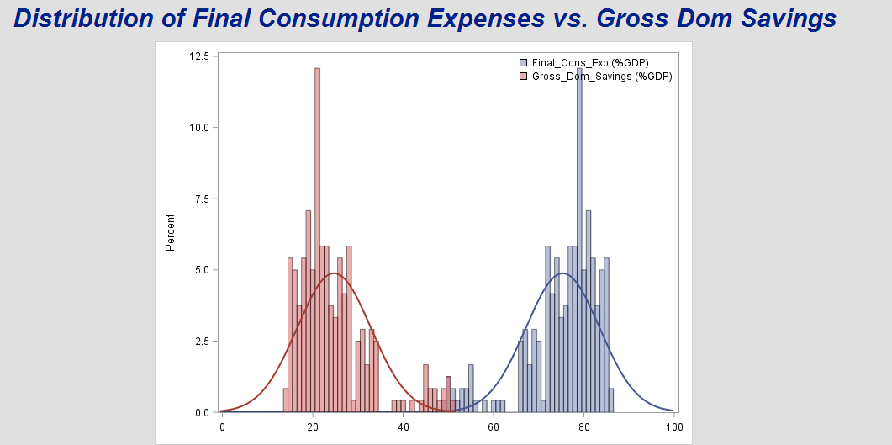

6. Outlier Detection -

/* 6. Outlier Detection - using Box plots (Explanatory Data Analysis)*/

ods graphics / reset width=**6.4**in height=**4.8**in imagemap;

**proc** **sgplot** data=WORK.G7_BRICS;

title 'Summary Stats - Gross Dom Savings';

vbox 'Gross_Dom_Savings (%GDP)'n / category='Country Name'n;

yaxis grid;

**run**;

ods graphics / reset;

/* Outliers detected for Russia */

ods graphics / reset width=**6.4**in height=**4.8**in imagemap;

**proc** **sgplot** data=WORK.G7_BRICS;

title 'Summary Stats - Imports_G&S';

vbox 'Imports_G&S (%GDP)'n / category='Country Name'n;

yaxis grid;

**run**;

ods graphics / reset;

/* Outliers detected for Brazil, Canada, South Africa & UK */

**proc** **sgplot** data=WORK.G7_BRICS noborder;

title 'Summary Stats - Inflation (%)';

hbox 'Inflation (%)'n / category= 'Country Name'n

group= 'Bloc'n clusterwidth=**0.5**

boxwidth=**0.8** meanattrs=(size=**5**)

outlierattrs=(size=**5**);

xaxis display=(noline nolabel noticks);

yaxis display=(noline noticks nolabel) grid;

**run**;

* Seems like China has amassed huge percentage of GDP as savings.

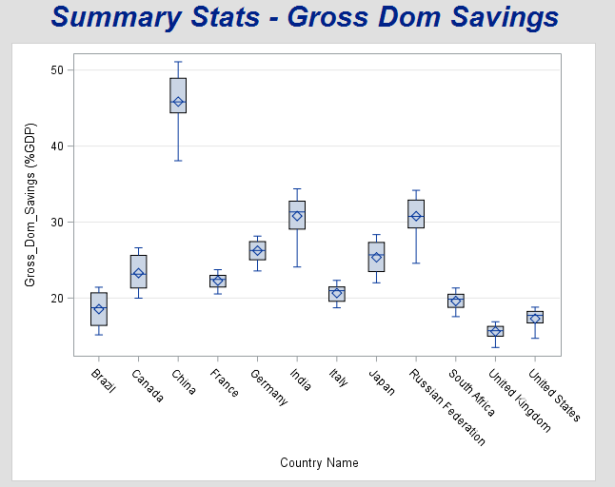

* We could see some outliers for Russian imports of goods and services due to multiple financial crises that happened during 2008 and 2014-17.

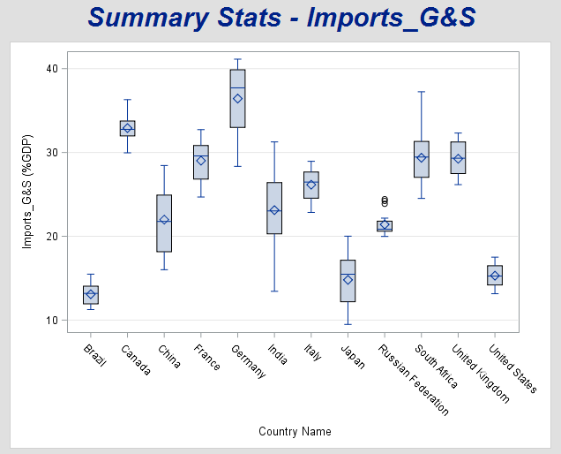

* Inflation between the group of countries looks like below. Outliers can be seen for Brazil, Canada, South Africa and the UK.

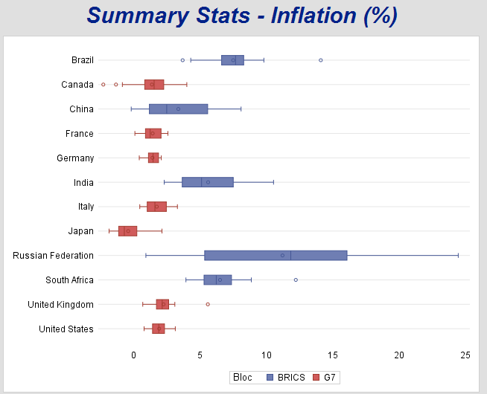

1. Comparative Analysis -

/* Comparative analysis */

/* 7. Grouping between various countries - G7 vs. BRICS */

/* Understanding relationships using groups / countries - Scatter plots */

ods graphics / reset width=**6.4**in height=**4.8**in imagemap;

**proc** **sgplot** data=WORK.G7_BRICS;

title "GDP vs. Agriculture, Forestry & Fishing";

scatter x='gdp (curr us$) in trillion'n y= 'Agr_For_Fish_ValueAdd (%GDP)'n / markerattrs=(symbol=triangle) group=Bloc;

**run**;

ods graphics / reset;

ods graphics / reset width=**6.4**in height=**4.8**in imagemap;

**proc** **sgplot** data=WORK.G7_BRICS;

title "GDP vs. Traded Stocks";

scatter x='gdp (curr us$) in trillion'n y='Stocks_traded_valueAdd (%GDP)'n / markerattrs=(symbol=triangle) group=Bloc;

**run**;

ods graphics / reset;

ods graphics / reset width=**6.4**in height=**4.8**in imagemap;

**proc** **sgplot** data=WORK.G7_BRICS;

title "GDP vs. Current Health Expenditure";

scatter x='gdp (curr us$) in trillion'n y='Curr_Health_Exp (%GDP)'n / markerattrs=(symbol=triangle) group=Bloc;

**run**;

ods graphics / reset;

ods graphics / reset width=**6.4**in height=**4.8**in imagemap;

**proc** **sgplot** data=WORK.G7_BRICS;

title "GDP vs. Energy use (kg of oil equivalent) per $1,000 GDP";

scatter x='gdp (curr us$) in trillion'n y='EnergyUse_per1000$GDP'n / markerattrs=(symbol=triangle) group=Bloc;

**run**;

ods graphics / reset;

ods graphics / reset width=**6.4**in height=**4.8**in imagemap;

**proc** **sgplot** data=WORK.G7_BRICS;

title "GDP vs. Energy use (kg of oil equivalent) per $1,000 GDP";

scatter x='gdp (curr us$) in trillion'n y='EnergyUse_per1000$GDP'n / markerattrs=(symbol=triangle) group=Bloc;

**run**;

ods graphics / reset;

ods graphics / reset width=**6.4**in height=**4.8**in imagemap;

**proc** **sgplot** data=WORK.G7_BRICS;

title "GDP vs. Exports of Goods & Services";

scatter x='gdp (curr us$) in trillion'n y='Exports of G&S (%GDP)'n / markerattrs=(symbol=triangle) group=Bloc;

**run**;

ods graphics / reset;

ods graphics / reset width=**6.4**in height=**4.8**in imagemap;

**proc** **sgplot** data=WORK.G7_BRICS;

title "GDP vs. Imports of Goods & Services";

scatter x='gdp (curr us$) in trillion'n y='Imports_G&S (%GDP)'n / markerattrs=(symbol=triangle) group=Bloc;

**run**;

ods graphics / reset;

ods graphics / reset width=**6.4**in height=**4.8**in imagemap;

**proc** **sgplot** data=WORK.G7_BRICS;

title "GDP vs. FDI, net inflows (%GDP)";

scatter x='gdp (curr us$) in trillion'n y='fdi, net inflows (%gdp)'n / markerattrs=(symbol=triangle) group=Bloc;

**run**;

ods graphics / reset;

ods graphics / reset width=**6.4**in height=**4.8**in imagemap;

**proc** **sgplot** data=WORK.G7_BRICS;

title "GDP vs. FDI, net inflows (%GDP)";

scatter x='gdp (curr us$) in trillion'n y='fdi, net outflows (%gdp)'n / markerattrs=(symbol=triangle) group=Bloc;

**run**;

ods graphics / reset;

ods graphics / reset width=**6.4**in height=**4.8**in imagemap;

**proc** **sgplot** data=WORK.G7_BRICS;

title "GDP vs. Personal_Remittances (%GDP)";

scatter x='gdp (curr us$) in trillion'n y='Personal_Remittances (%GDP)'n / markerattrs=(symbol=triangle) group=Bloc;

**run**;

ods graphics / reset;

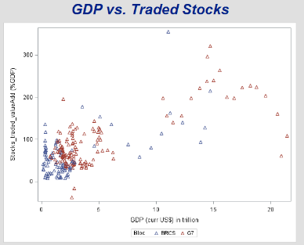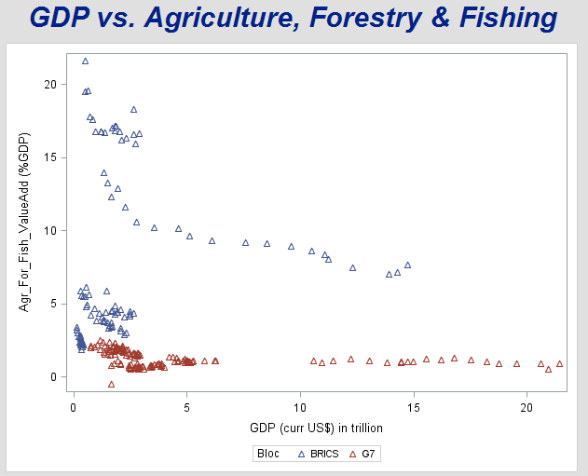

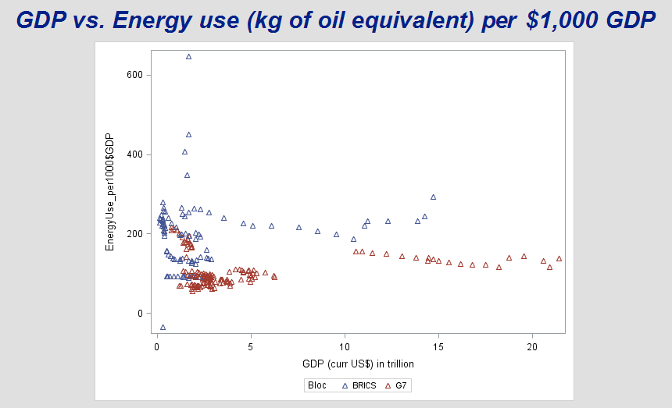

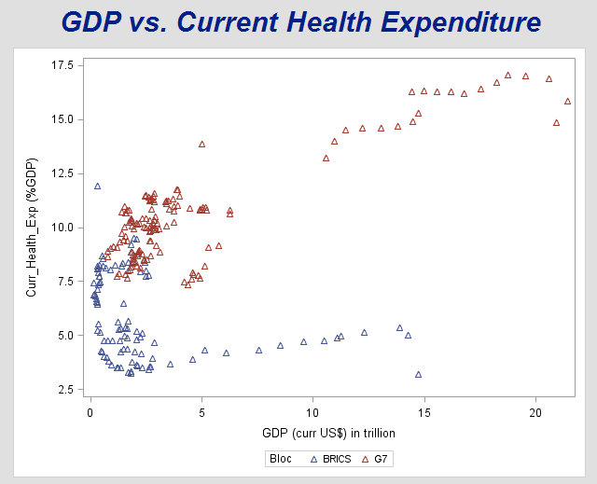

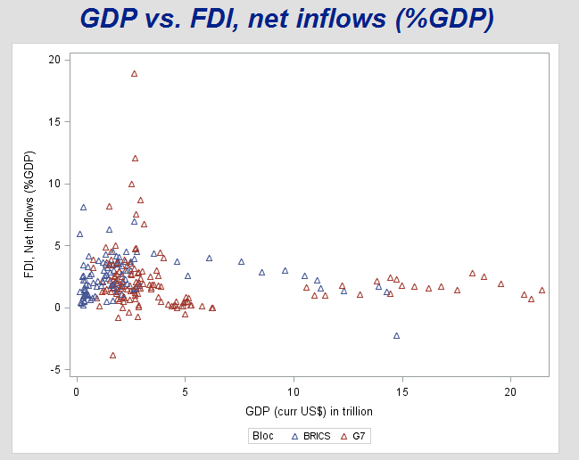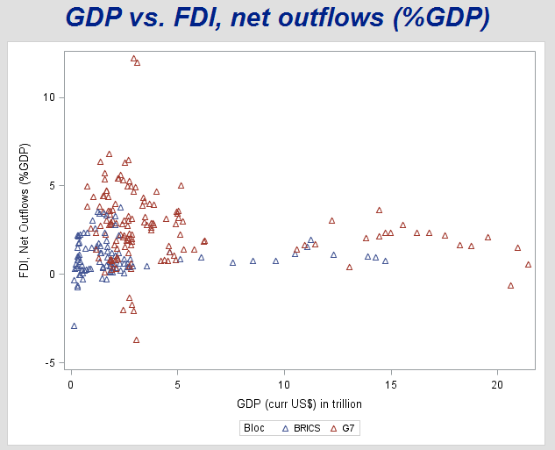

1. Correlation Analysis

/* 8. Correlation Analysis*/

/* Correaltion among numeric variables */

ods noproctitle;

ods graphics / imagemap=on;

**proc** **corr** data=WORK.G7_BRICS pearson nosimple noprob plots=none;

**run**;

/*Correlation by Bloc*/

**proc** **sgscatter** data=WORK.G7_BRICS;

matrix 'Agr_For_Fish_ValueAdd (%GDP)'n--'Final_Cons_Exp (%GDP)'n /group=Bloc diagonal=(histogram kernel);

**run**;

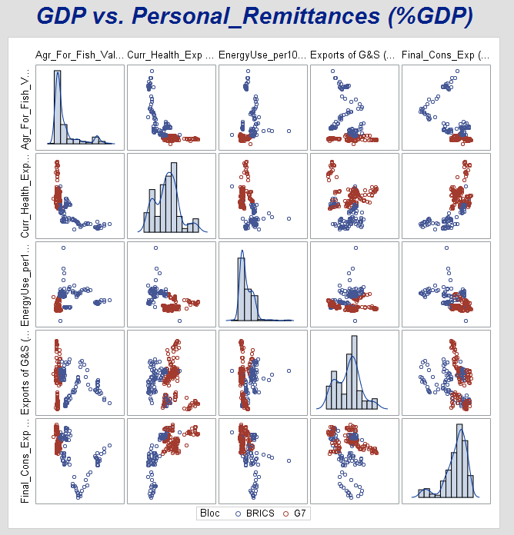

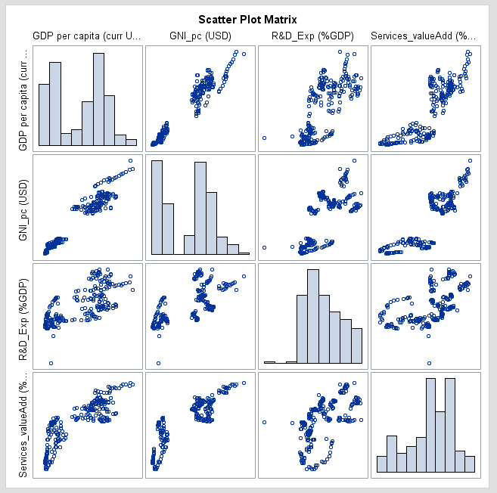

* Strong negative correlations and strong positive correlations are identified based on the correlation coefficients.

/*Strong Negative Correlations*/

**proc** **corr** data=WORK.G7_BRICS plots=matrix(histogram);

var 'Agr_For_Fish_ValueAdd (%GDP)'n 'Services_valueAdd (%GDP)'n;

**run**;

**proc** **corr** data=WORK.G7_BRICS plots=matrix(histogram);

var 'Final_Cons_Exp (%GDP)'n 'Industry_valueAdd (%GDP)'n;

**run**;

**proc** **corr** data=WORK.G7_BRICS plots=matrix(histogram);

var 'Final_Cons_Exp (%GDP)'n 'Manufacturing_valueAdd (%GDP)'n;

**run**;

**proc** **corr** data=WORK.G7_BRICS plots=matrix(histogram);

var 'Final_Cons_Exp (%GDP)'n 'Gross_Dom_Savings (%GDP)'n;

**run**;

**proc** **corr** data=WORK.G7_BRICS plots=matrix(histogram);

var 'Industry_valueAdd (%GDP)'n 'Services_valueAdd (%GDP)'n;

**run**;

/*Strong Positive Correlations*/

**proc** **corr** data=WORK.G7_BRICS plots=matrix(histogram);

var 'Agr_For_Fish_ValueAdd (%GDP)'n 'Personal_Remittances (%GDP)'n;

**run**;

**proc** **corr** data=WORK.G7_BRICS plots=matrix(histogram);

var 'Curr_Health_Exp (%GDP)'n 'gdp per capita (curr us$)'n 'GNI_pc (USD)'n 'Services_valueAdd (%GDP)'n;

**run**;

**proc** **corr** data=WORK.G7_BRICS plots=matrix(histogram);

var 'Imports_G&S (%GDP)'n 'Exports of G&S (%GDP)'n 'Trade (%GDP)'n 'Trade in services (%GDP)'n;

**run**;

**proc** **corr** data=WORK.G7_BRICS plots=matrix(histogram);

var 'gdp (curr us$) in trillion'n 'Stocks_traded_valueAdd (%GDP)'n;

**run**;

**proc** **corr** data=WORK.G7_BRICS plots=matrix(histogram);

var 'gdp per capita (curr us$)'n 'GNI_pc (USD)'n 'r&d_exp (%gdp)'n 'Services_valueAdd (%GDP)'n;

**run**;

**proc** **corr** data=WORK.G7_BRICS plots=matrix(histogram);

var 'Gross_Dom_Savings (%GDP)'n 'Industry_valueAdd (%GDP)'n 'Manufacturing_valueAdd (%GDP)'n;

**run**;

1. Summary Stats of Inflation % (To be used for hypothesis testing later)

/* 9. G7 vs BRICS */

/* The null hypothesis is that the Inflation is always ~2% for each of the countries */

**proc** **sgplot** data=WORK.G7_BRICS noborder;

title 'Summary Stats - Inflation (%)';

hbox 'Inflation (%)'n / category= 'Bloc'n

group= 'Bloc'n clusterwidth=**0.5**

boxwidth=**0.8** meanattrs=(size=**5**)

outlierattrs=(size=**5**);

xaxis display=(noline nolabel noticks);

yaxis display=(noline noticks nolabel) grid;

**run**;

* Output -

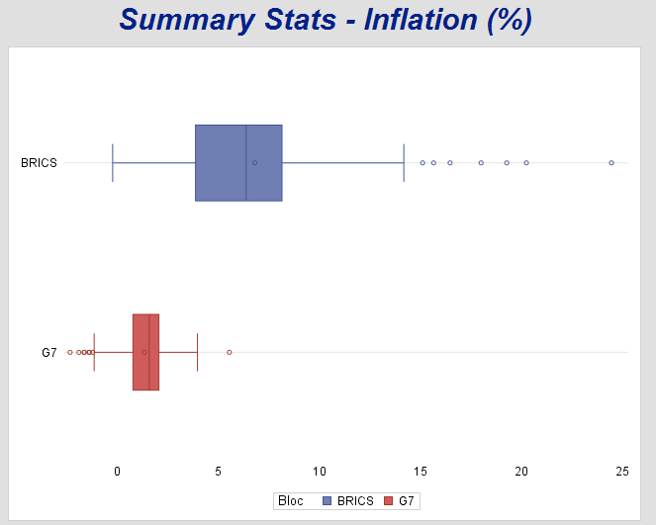

# 4. Analysis

Firstly, we would compare the individual blocs in order to find characteristic trends and patterns. Later, we apply statistical analysis on all the countries together.

## 4.1 Statistical analysis with data subsets

1. 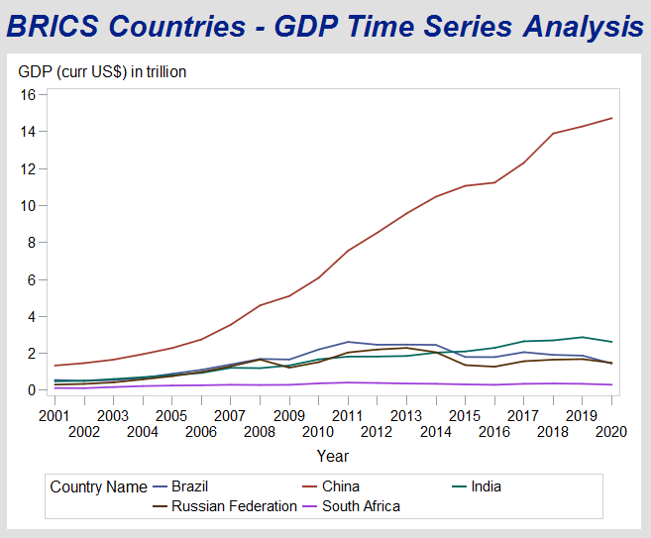GDP Time Series Analysis – G7 vs. BRICS

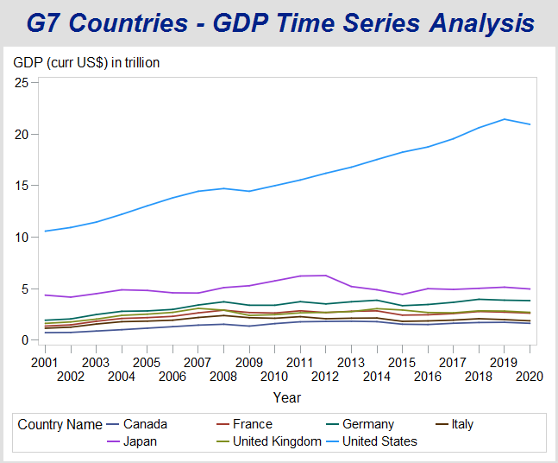

1. Summary Stats for Value Adds % GDP – G7 vs. BRICS

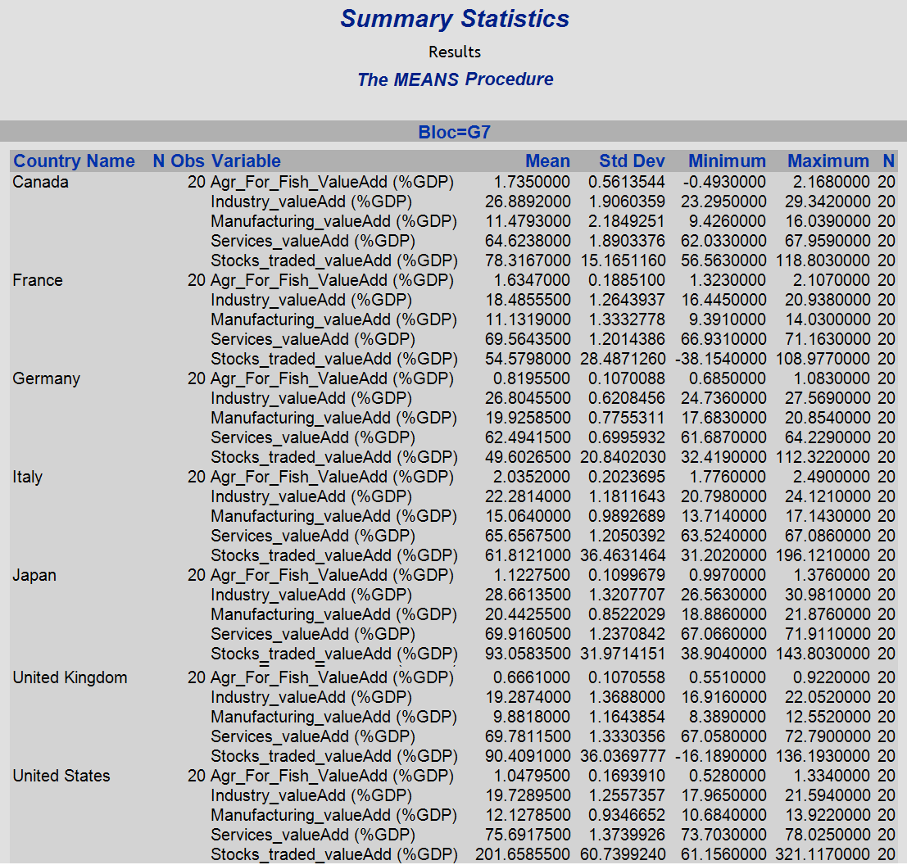

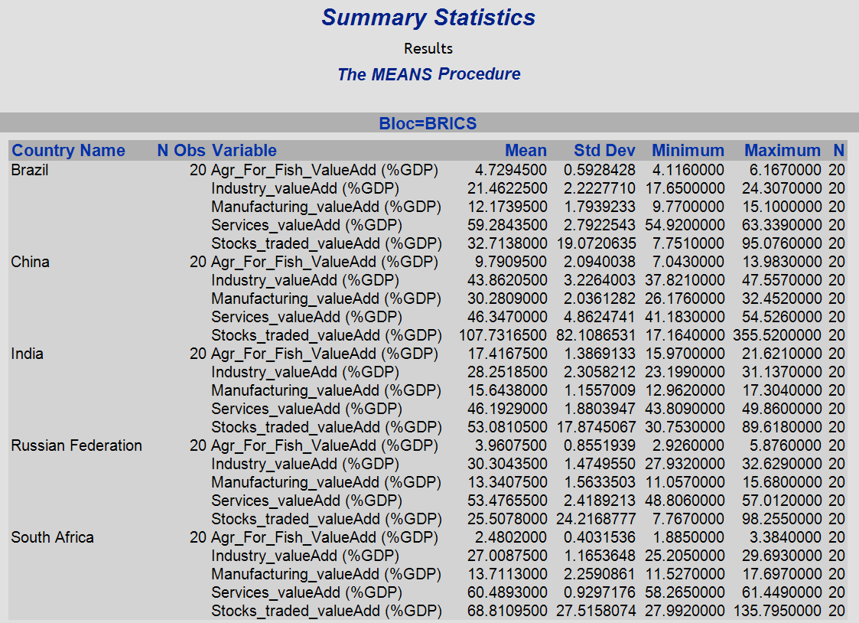

1. 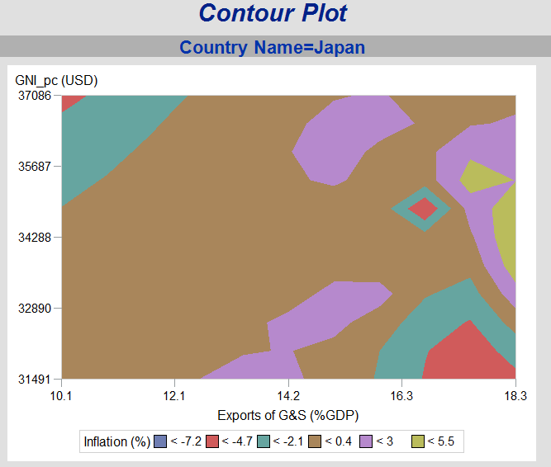Contour Plots G7 vs. BRICS

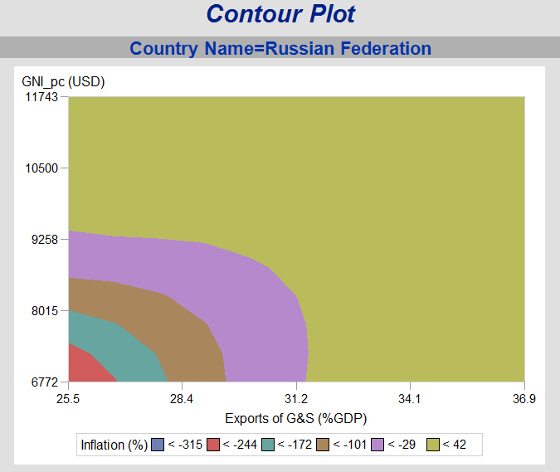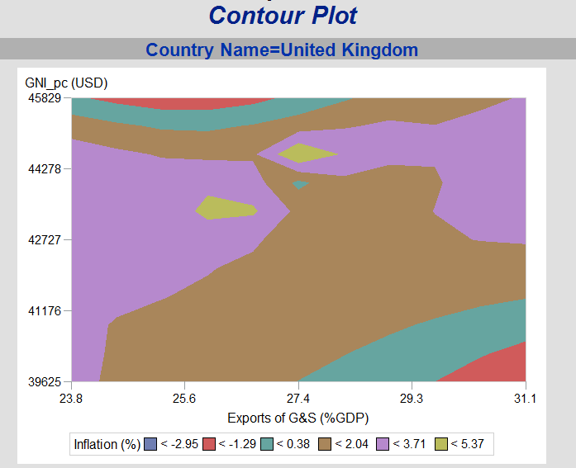

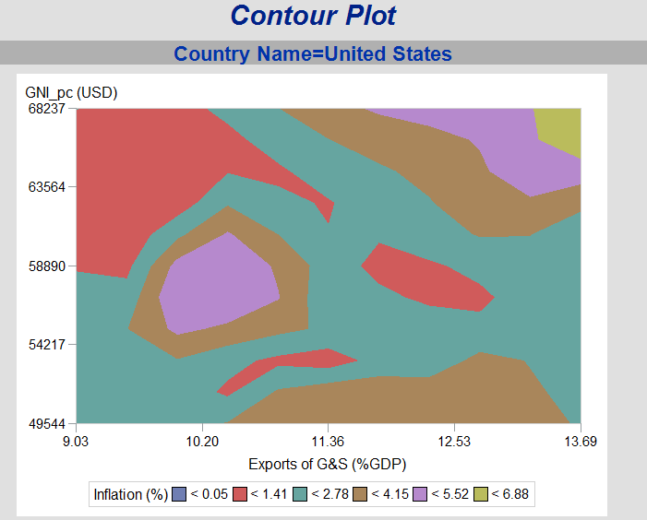

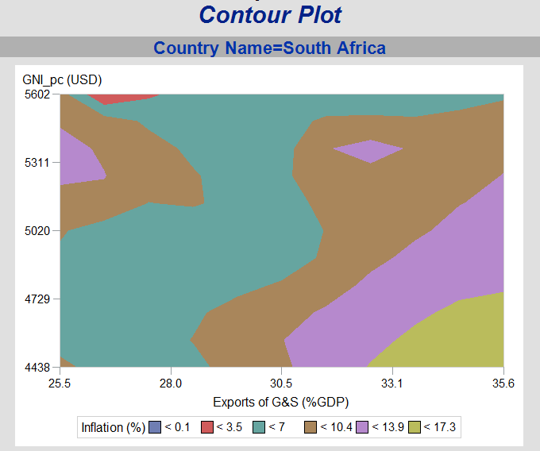

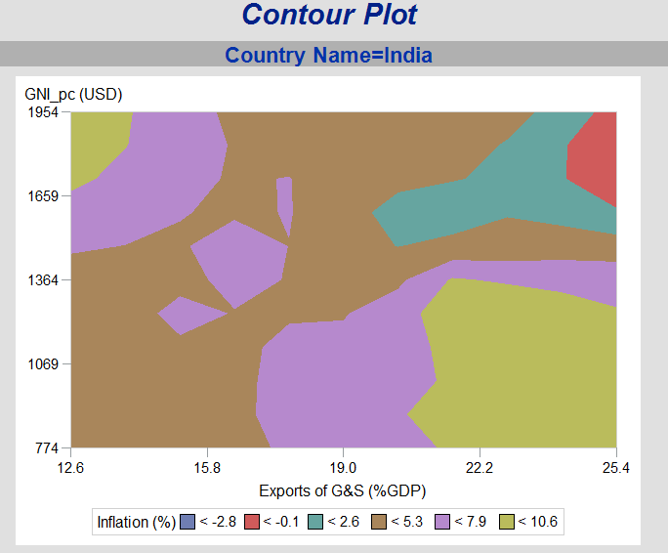

1. **Linear Regression** –
   1. Bloc = G7

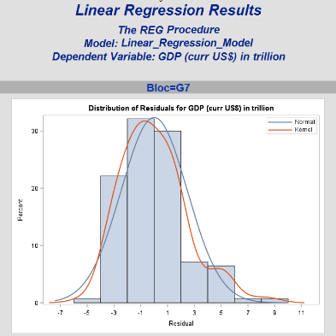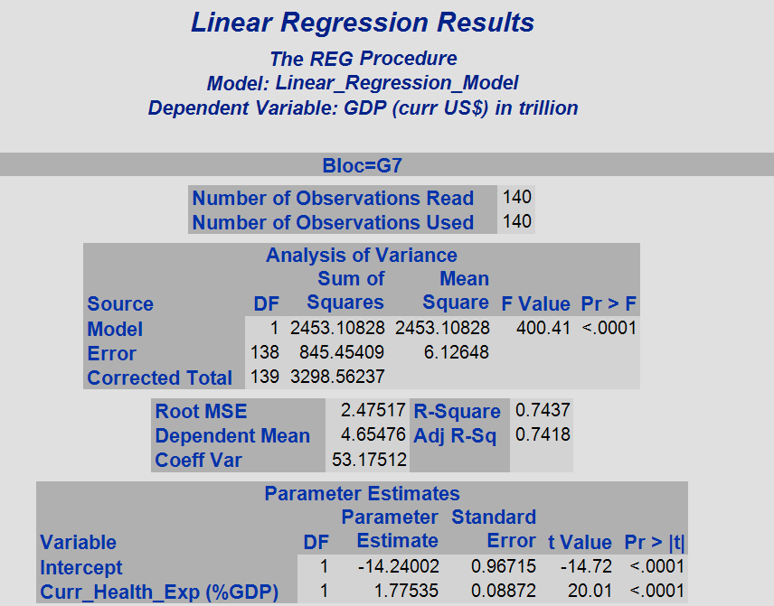

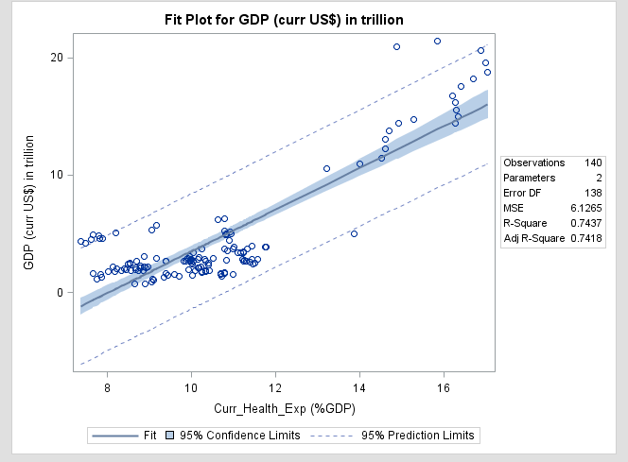

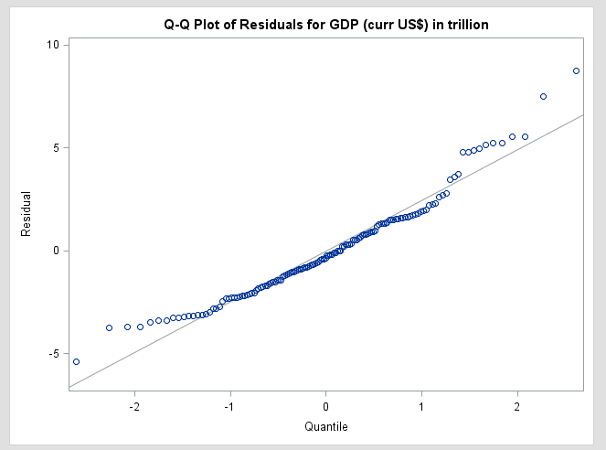

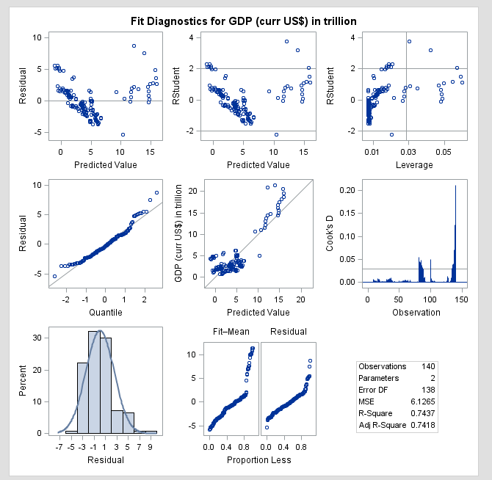

* 1. 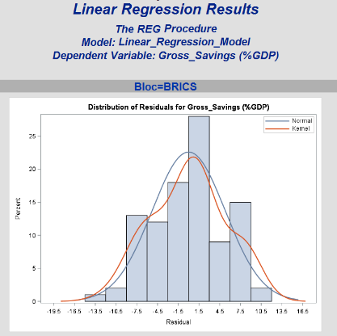Bloc = BRICS

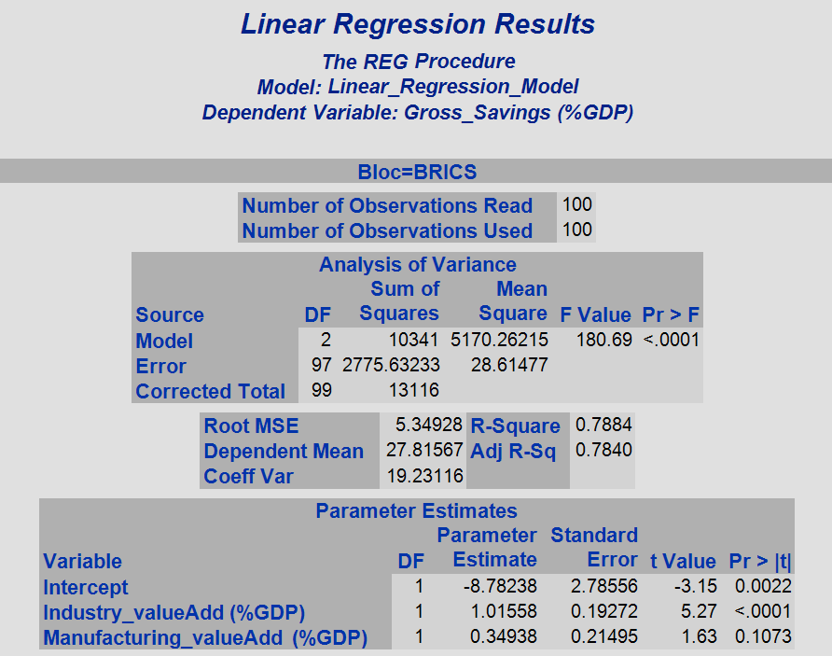

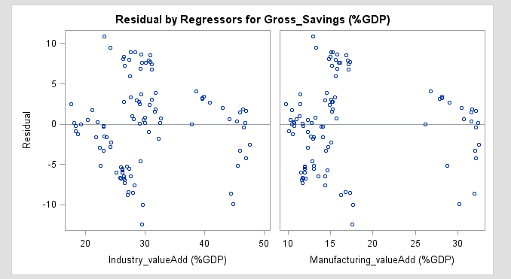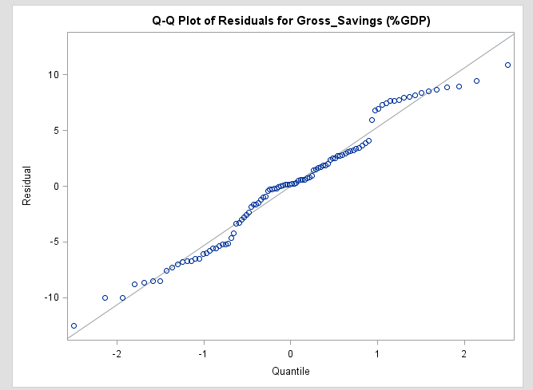

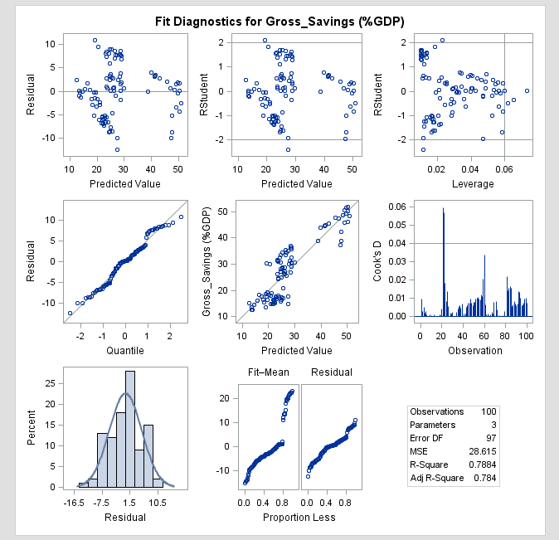

## 4.2 Statistical Analysis based on grouping

### 4.2.1Simple Linear Regression – GDP and Current Health Expenditure (% GDP)

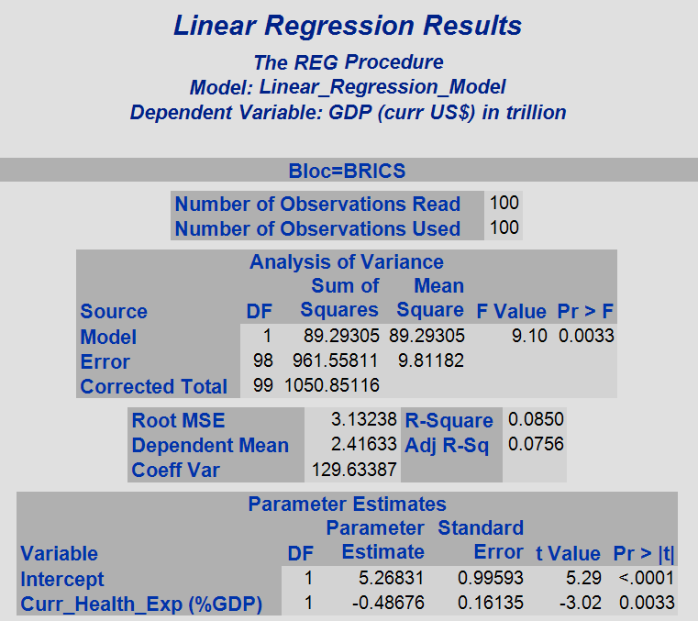

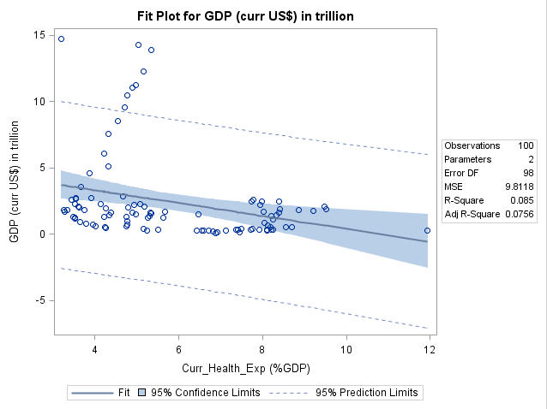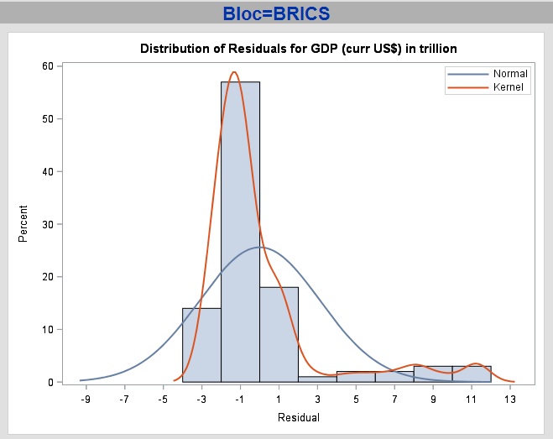

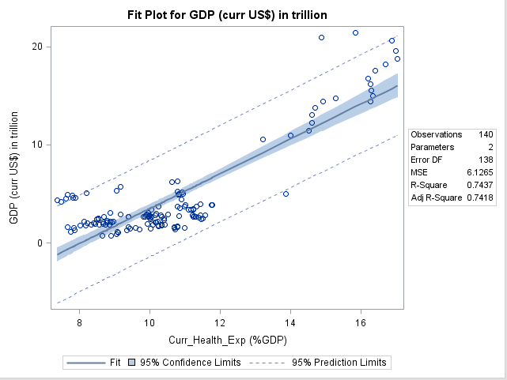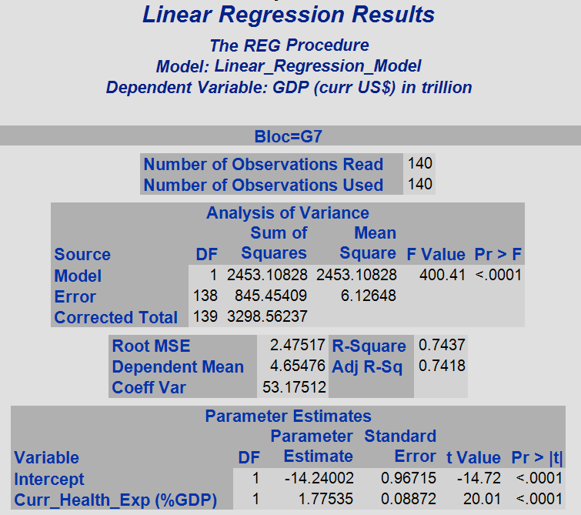

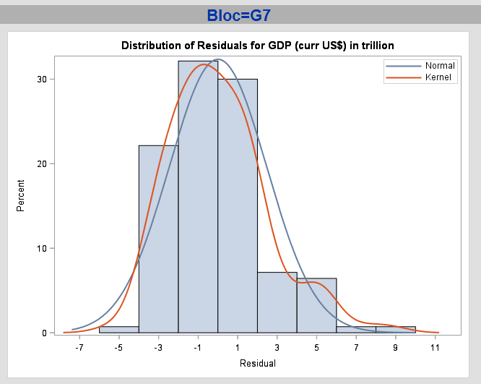

### 4.2.2 Multiple Linear Regression – G7 and BRICS together

* 1. Total Expenditure vs. (Industry Value Add + Manufacturing Value Add + Agriculture, Forestry and Fishing Value Add % GDP)

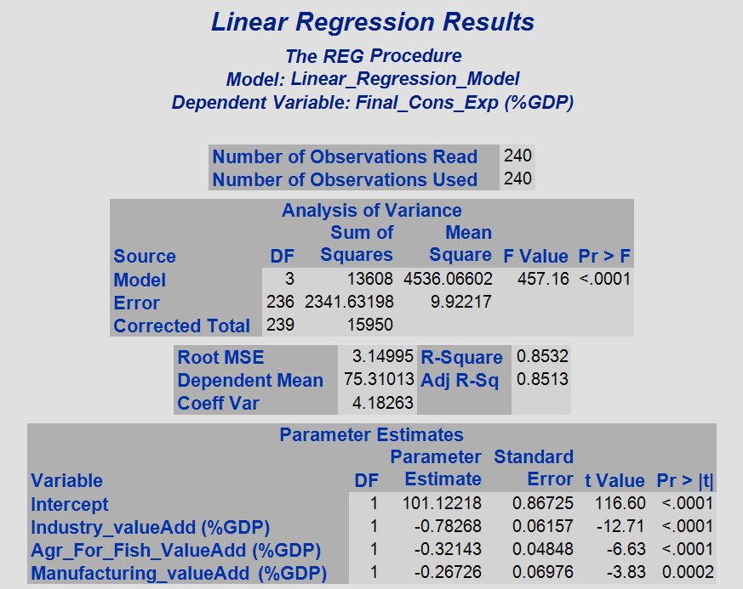

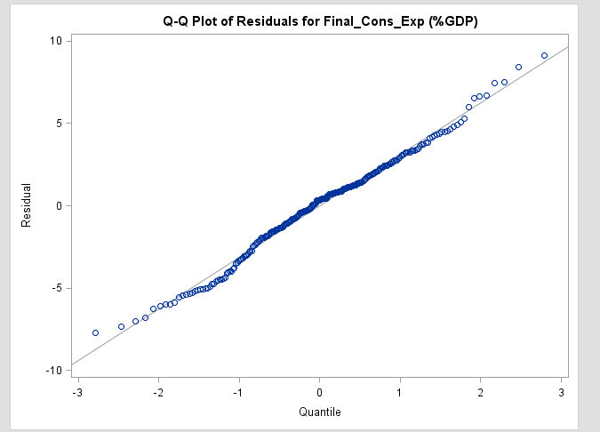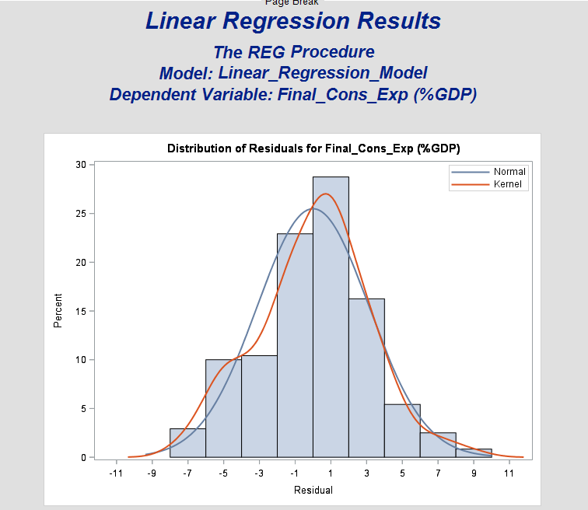

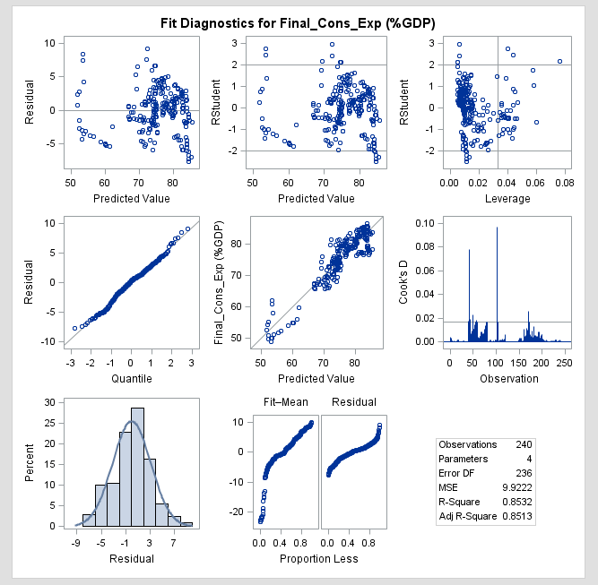

### 4.2.3 Non linear regression – Inflation vs. Stocks traded

* Bloc = BRICS

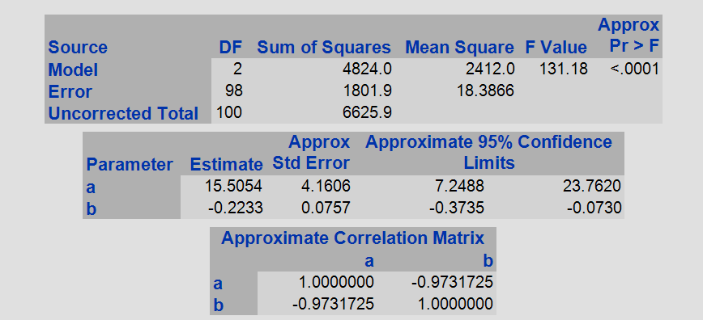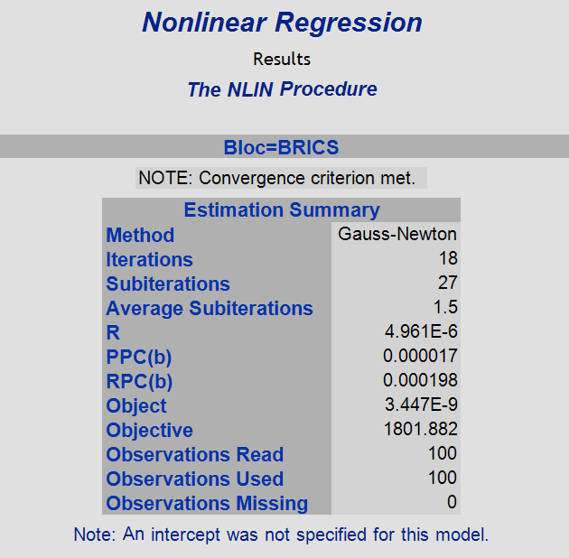

* Bloc = G7

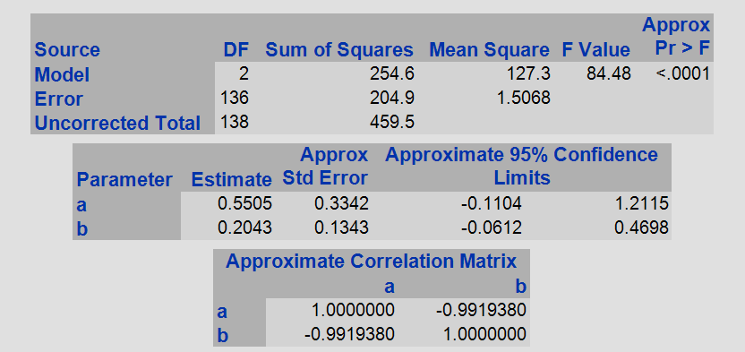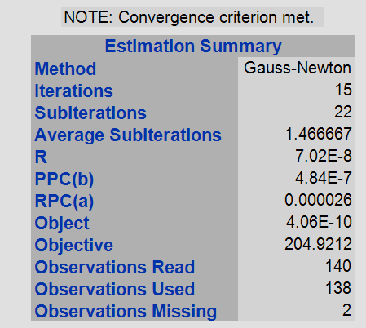

### 4.2.4 Hypothesis testing

* According to economic growth, the average inflation rate needs to be 2% over the last 20 years in order to have a progressive economy despite any challenges globally or nationally. In case it doesn’t appear to be within this range, we consider this as an alternative hypothesis, or else, we would accept the null hypothesis and consider the economy is progressive. Here p-value is greater than 0.05, which means the data is statistically significant.
* We are using a t-Test here since we are looking into a single continuous variable. Alternatively, based on the variable type – categorical, discrete, multiple variables, etc we’ll have to use other tests in order to perform hypothesis testing – for example OLS regression, ANOVA, etc.
* The countries that qualified for Null hypothesis (h0) – Canada, Italy, UK and USA.
* All the other countries satisfy the alternative hypothesis.
* Japan is a special case since this progressive economy has deflation.

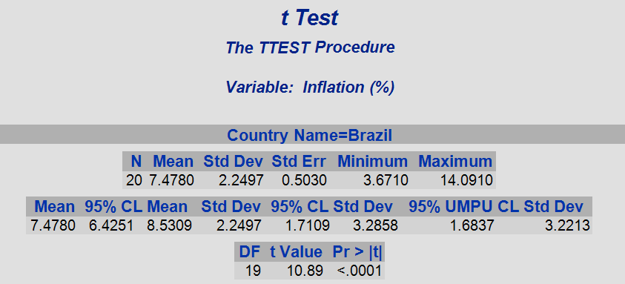

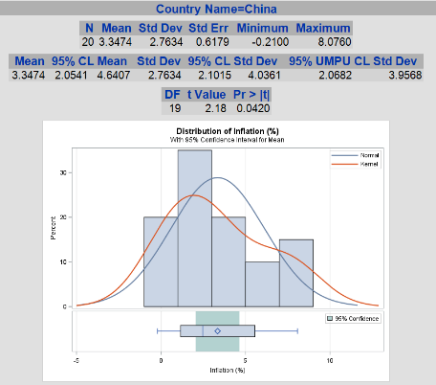

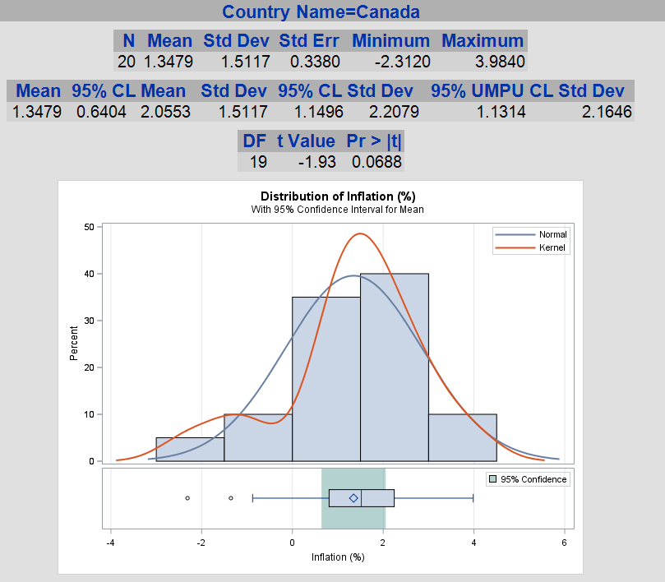

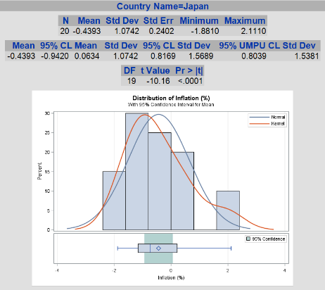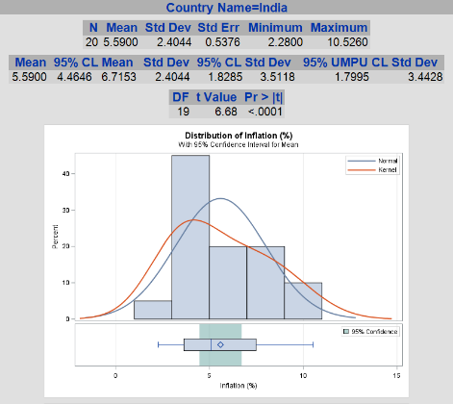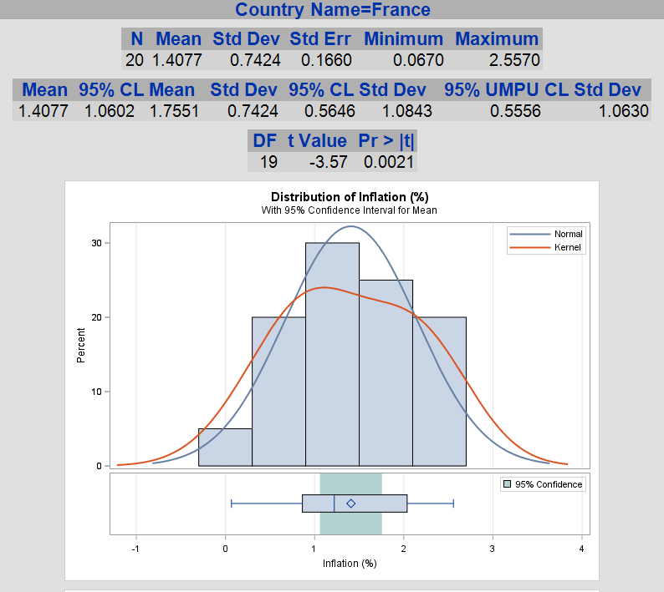

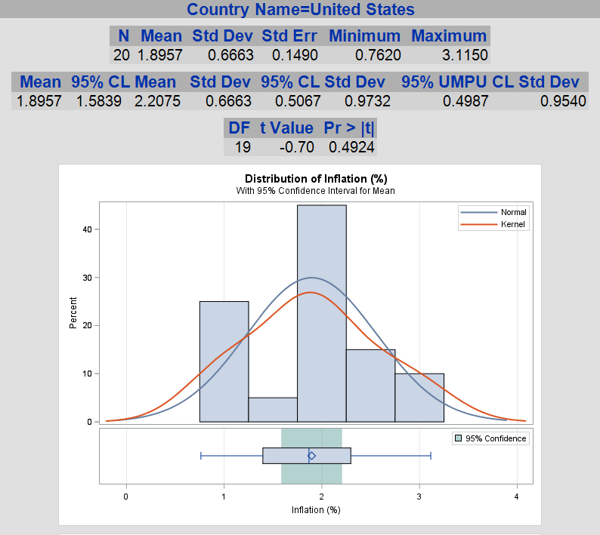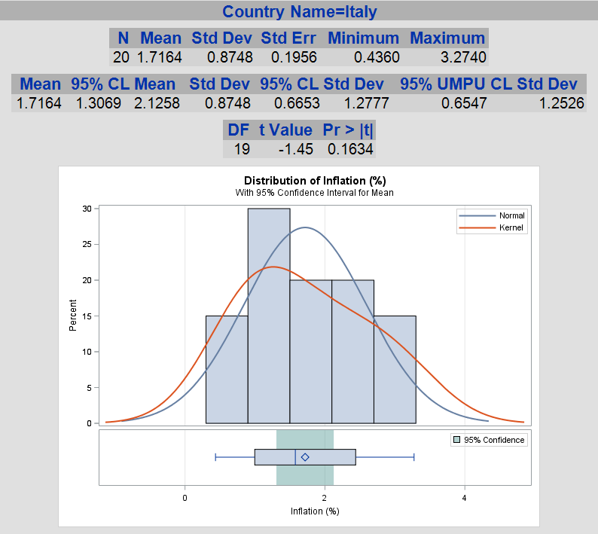

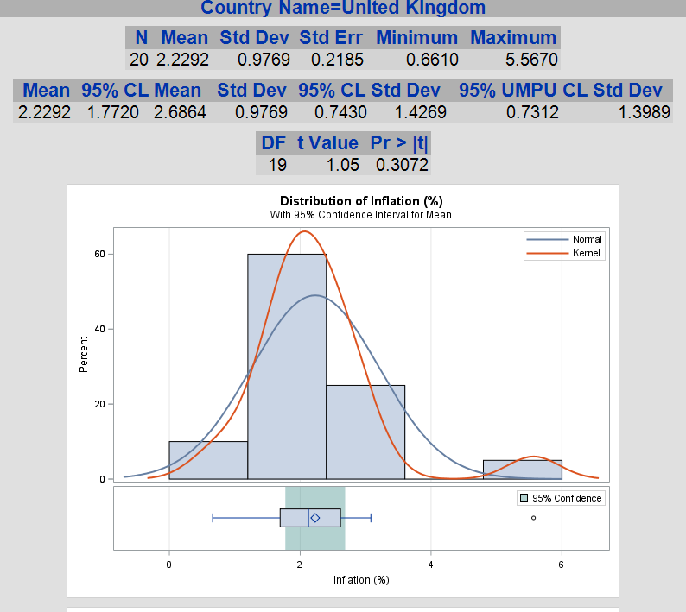

### 4.2.5 ANOVA procedure

* If we consider 1 categorical and 1 continuous variables.

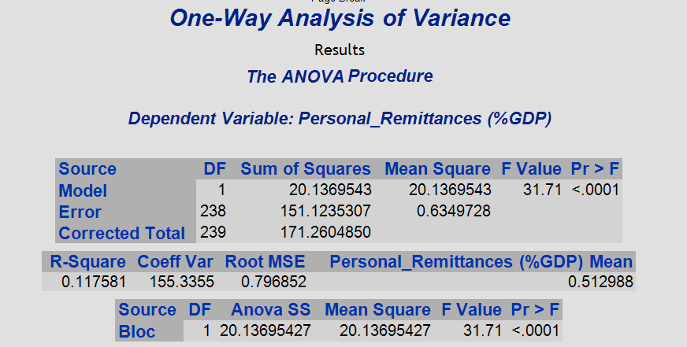

### 4.2.6 Principal Component Analysis

* 1. Bloc = BRICS

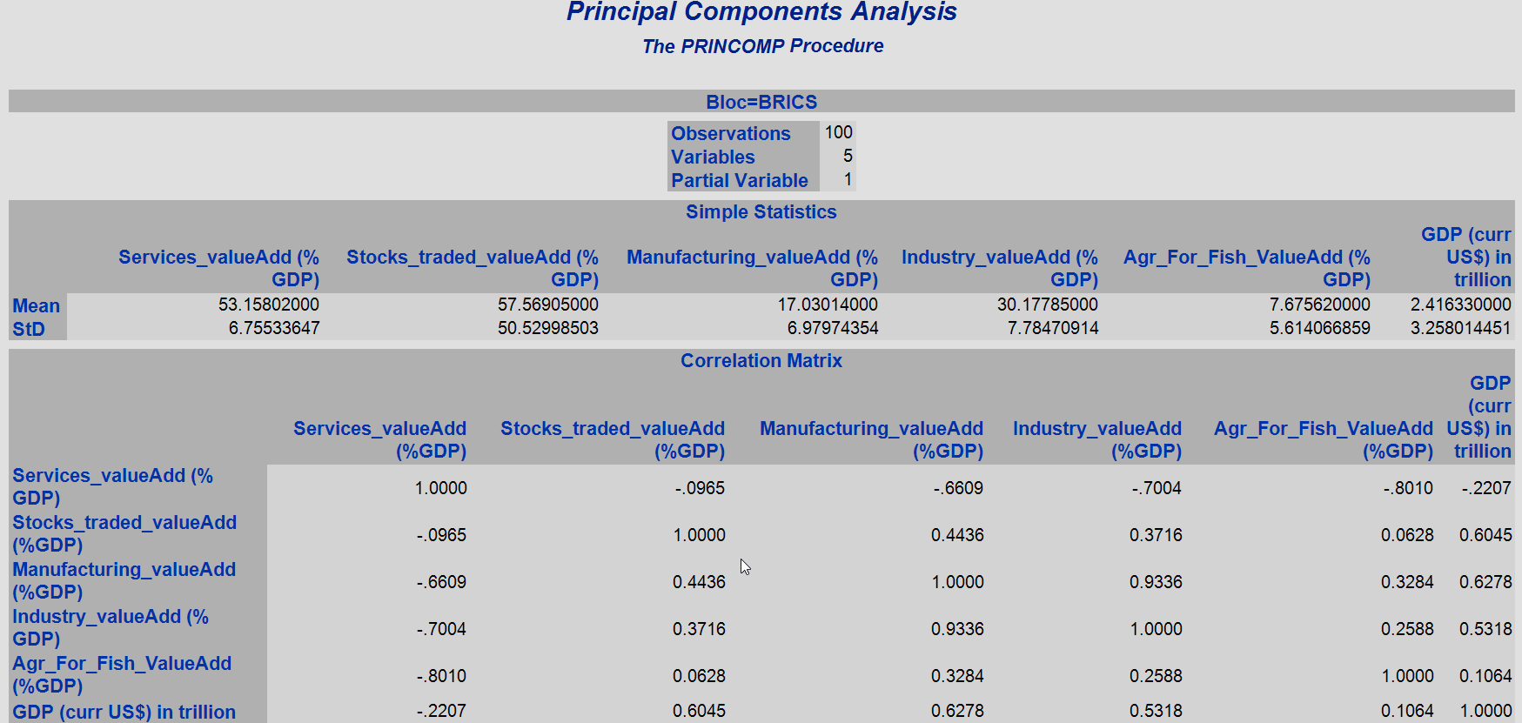

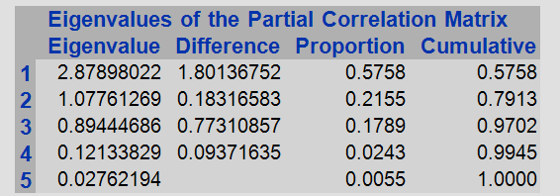

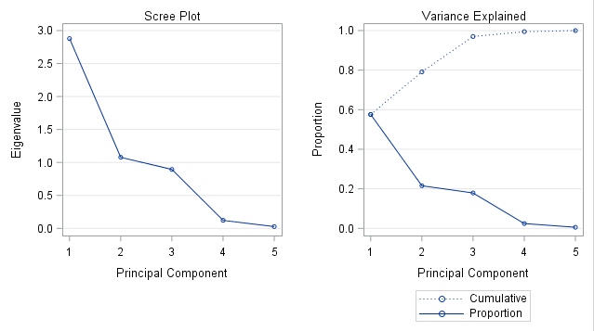

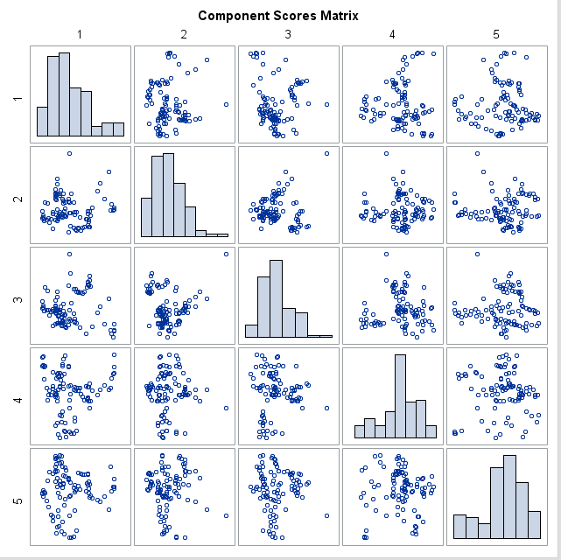

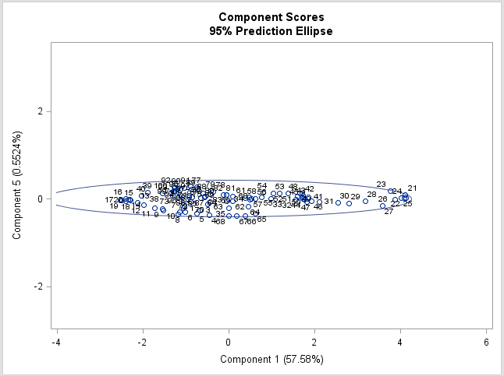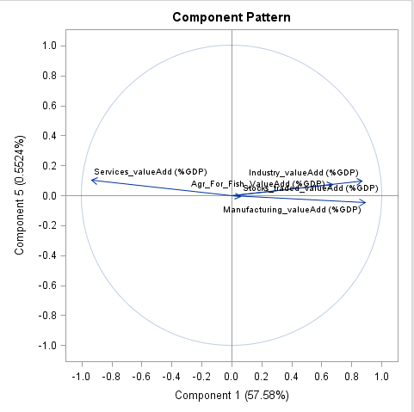

* 1. Bloc = G7

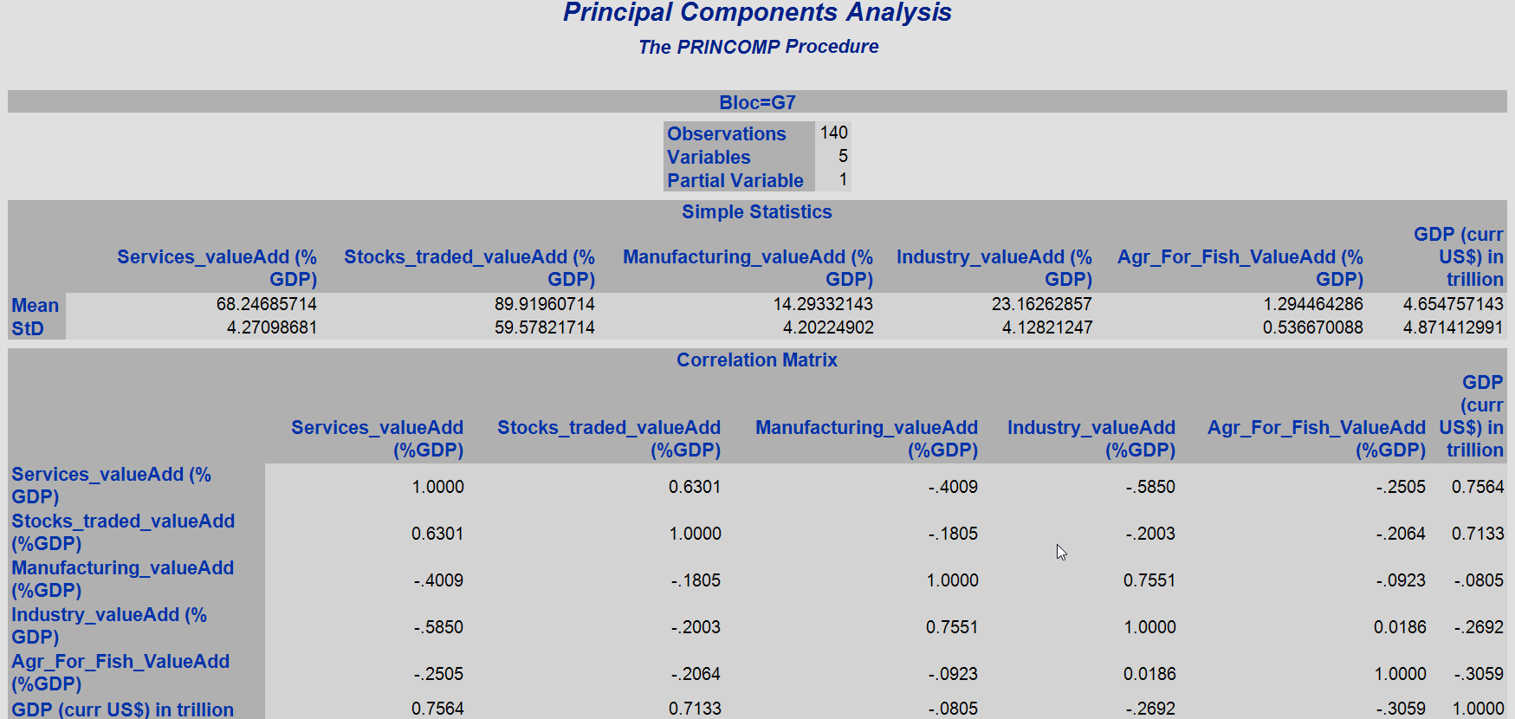

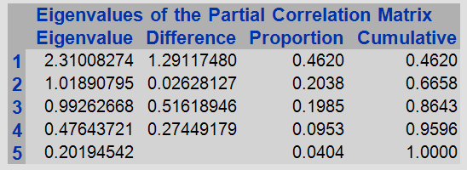

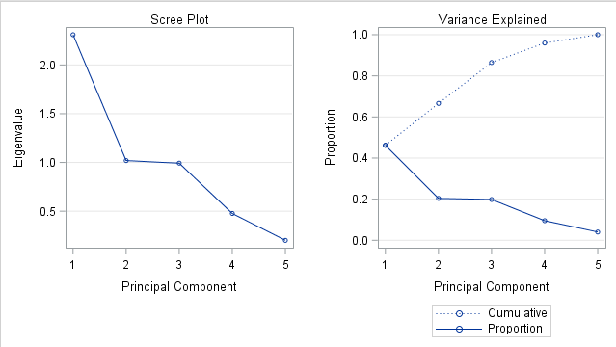

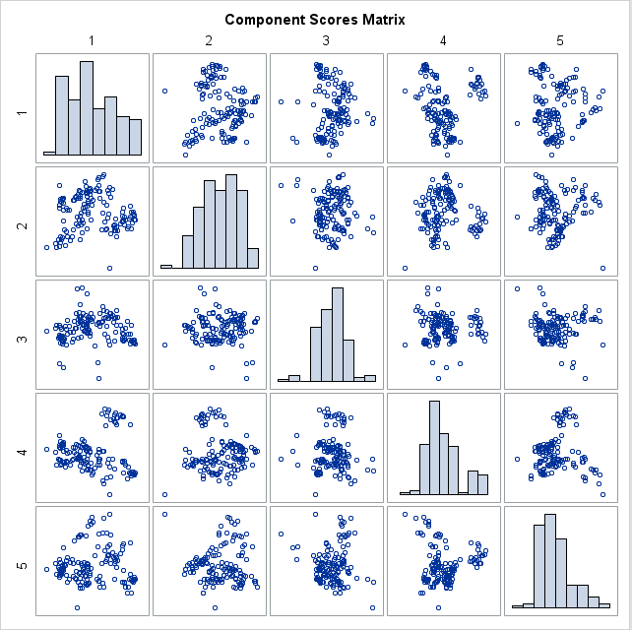

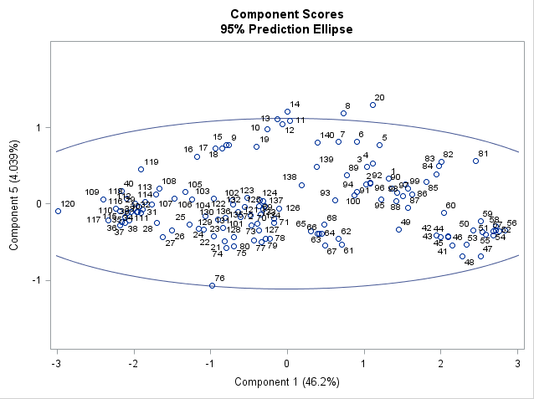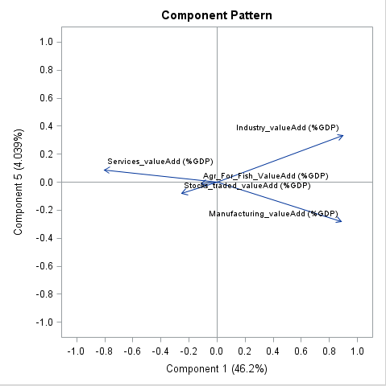

# Discussion

* In essence, there are 12 countries, 20 years and 240 observations for 24 continuous variables.
* During the outlier detection, we discovered that China had amassed an average of 40% of GDP as Gross savings over the years. Outliers were detected for Russia for Imports of goods & services since Russia had to go through multiple financial crises in 2008 and 2014-17. Also there were outliers detected for Brazil, Canada, South Africa and the UK for inflation rate.
* We used histograms, boxplots, correlelograms, matrices, tables, scatter plots, etc to present all the statistical findings from the dataset.
* Strong correlations and weak correlations can be determined based on the correlation coefficient and R-value along with adjusted R-value. IF the R-value is greater than 70% and p-value is less than 5% , that means we could proceed with a regression model for the correlation defined.
* There were strong negative correlations between
  + Total expenditure and Industry Value Add % GDP,
  + Total expenditure and Manufacturing Value Add % GDP,
  + Industry value add % GDP and Services as a Value Add % GDP,
  + Agriculture, Forestry and Fishery as a value add % GDP and Services as a value add % GDP.
* In contrast, there were strong positive correlations between
  + Agriculture, Forestry and Fishery as a value add % GDP and Personal Remittances (% GDP),
  + Current Health Expenditure (%GDP) and GDP per capita (US $) and GNI per capita and Services Value add % GDP,
  + Imports, Exports and Trade % GDP,
  + GDP and stocks traded as value add (% GDP),
  + GDP per capita, GNI per capita, R&D expenditure (% GDP), Services Value add (% GDP),
  + Gross Domestic Savings, Industry Value add and Manufacturing value add,
* Within data subsets, we could observe that USA is the fastest growing economy within G7 and China is the fastest growing within BRICS.
* For stocks traded value add % GDP, USA and China have the highest standard deviations and Canada and India have the lowest standard deviation in G7 and BRICS nations respectively.
* Using Linear regression, for G7 bloc, we could observe that GDP can be considered as a Dependent variable and Current Health Expenditure (% GDP) can be considered as an independent variable resulting in an R-squared value of 74% and adjusted R-squared of 74%, and p value is less than 0.5 which means these numbers are statistically significant. We could also notice QQ plots showing the normally distributed residuals confirming the relevance along with fit diagnostics that would prove the goodness of fit.
* Using Linear regression, for BRICS bloc, we could observe that Gross Savings (% GDP) can be considered as a Dependent variable and Industry Value add (% GDP) can be considered as an independent variable resulting in an R-squared value of 78% and adjusted R-squared of 78%, and p value is less than 0.5 which means these numbers are statistically significant. We could also notice QQ plots showing the normally distributed residuals confirming the relevance along with fit diagnostics that would prove the goodness of fit.
* Similarly, for both the blocs together, we see that the final consumption expenditure (% GDP) can be determined using independent variables - Industry and Manufacturing value adds along with Agriculture, forestry and fishery value add % GDP with an R-squared of 85% and p-value less than 5%. This was possible through multiple linear regression.
* Using the non-linear regression, we could observe that a relationship can be built using Inflation and Stocks traded with a strong negative correlation for both the bloc categories.
* During the hypothesis testing, our null hypothesis was that inflation rate was at 2 % as an average over the 20 years in order to have a progressive economy despite any challenges globally or nationally, and only Canada, USA, UK and Italy have qualified for this null hypothesis where in these countries are said to undergo massive economic boost going forward assuming a steady state of economy. This was achieved using a t-Test since we looked into a single continuous variable. Unfortunately none of the BRICS countries came close to the optimum inflation rate except China, and this would rank China as a better performer within the BRICS nations. Japan would be a special case since it has negative inflation over the years which would mean the economy has been progressive, but unsure as to how to tackle during a financial crisis based on our assumptions.
* Later we used One-Way Analysis of Variance (ANOVA) procedure for the dependent variable - Personal remittances (% GDP) and bloc (either G7 or BRICS) as independent variable and thus the R-squared value is only 11% which is not satisfactory, and thus we won't be able to use this procedure satisfactorily.
* In the end, we performed Principal component analysis to reduce dimensionality and read through the importance within the given variables through their Eigen values. For example, among the value adds of % GDP variables, it seems like Services_value_Add % GDP & Stocks traded as a value add %GDP have 79% of information regarding GDP, and they could be considered as worthy components to predict or interpret the forthcoming GDP in an ideal scenario. This applied for both the blocs (G7 and BRICS).
* Regarding the data security aspect which would mean our analysis report and process is part of a data protection plan, we could use the ability of persistence of the credentials which is part of the SAS application. In real world, a user cannot simply login to a server without proper credentials, and thus data could be protected based on the library, server and the administrative rights and roles that can be given to a user. Since, we are using a student edition of SAS, we do not have full application access and thus our activity is limited in this area of data ethics. SAS Viya is a cloud platform for statistical analysis solutions that can engage into GDPR policies based on the country, region and platform specifications.

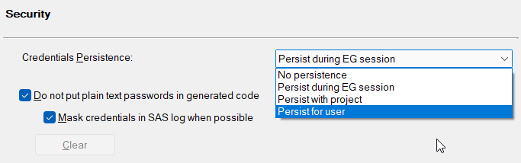

# Conclusions

In conclusion, I strongly believe that this SAS-based data science project is created to analyse financial data for 2 different groups of countries – G7 and BRICS, with an objective to statistically bring out meaningful insights and knowledge from the information present in the form of raw data and it has fulfilled the objective. We utilized the skillset and knowledge to cleanse, transform and model the data to fit into the statistically sound phenomena, and produce relevant, comprehensive, in-depth knowledge from scratch. We also managed to use an algorithm like Expectation-Maximization as part of the imputation technique, besides various procedures within SAS enterprise guide, along with the UI-based functionality to produce a consistent, reproduceable and scalable solution. G7 and BRICS nations data are collectively utilized to create this mammoth project and the solution would be to walk the path of the statistically better nation from each of these groups which would be USA and China.

# References

1. Wikipedia - <https://en.wikipedia.org/wiki/Group_of_Seven>
2. Wikipedia - <https://en.wikipedia.org/wiki/BRICS>

   iii. Statistics for Business and Economics – 9th Edition by Paul Newbold